Open Source Intelligence

*Student Name: Francesca Nicole Pinhal*

*Student ID: 10334601*

*Module: Computer Security*

**Question 1**

You have just joined a cyber security company and you are about to assist one of the engineers with the preparation of security audit for two of the company customers. It is just an initial phase and your customers haven't signed penetration testing authorisation form, NDA is not in place yet. However, you have been asked to establish what digital footprint, important to security audit, can be obtained using an open source intelligence technics.

You are specifically asked to **do not engage your target objective in any active form** - any form of scanning, phishing, social engineering is outside of scope of the engagement at the moment.

There are various open source intelligence technics that can be applied to security audit without engaging with the target. Open source intelligence (OSINT) is information collected from public sources such as those available on the internet, the term isn’t strictly limited to the internet but rather means all publicly available resources.

For investigation and research, we are going to use the most popular OSINT techniques used in cyber security such as:

* Collect employee full names, job roles as well as the software they use.
* Review and monitor search engine information from google, Bing, Yahoo and others.
* Identify social networks used by the target user or company.
* Review content available on social networks like Facebook, Twitter or LinkedIn.
* Identify mobile phone numbers, as well as mail addresses from google results.
* Explore DNS services, as well as domains, subdomains and IP addresses
* Use tools to search for internet-connected devices like Shodan.

TARGET 1: <https://computersuperheroes.com>

First of all we are going to start by looking for information related to our target computersuperheroes.com . Using the Ping tool in Kali Linux we can get the IP Address of the targeted domain which is 70.39.248.225. This simply means computer superheroes is connected to a network. We can also see the time taken which is shown in milliseconds in the screenshot below.

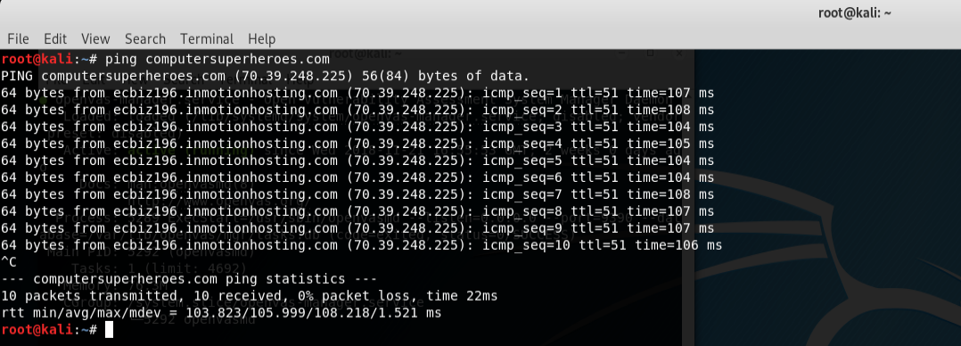

We can traceroute the target server, this will give us the information about the location and routing of the target. We use traceroute when we know the web address or the IP address of another computer. See snap shot below.

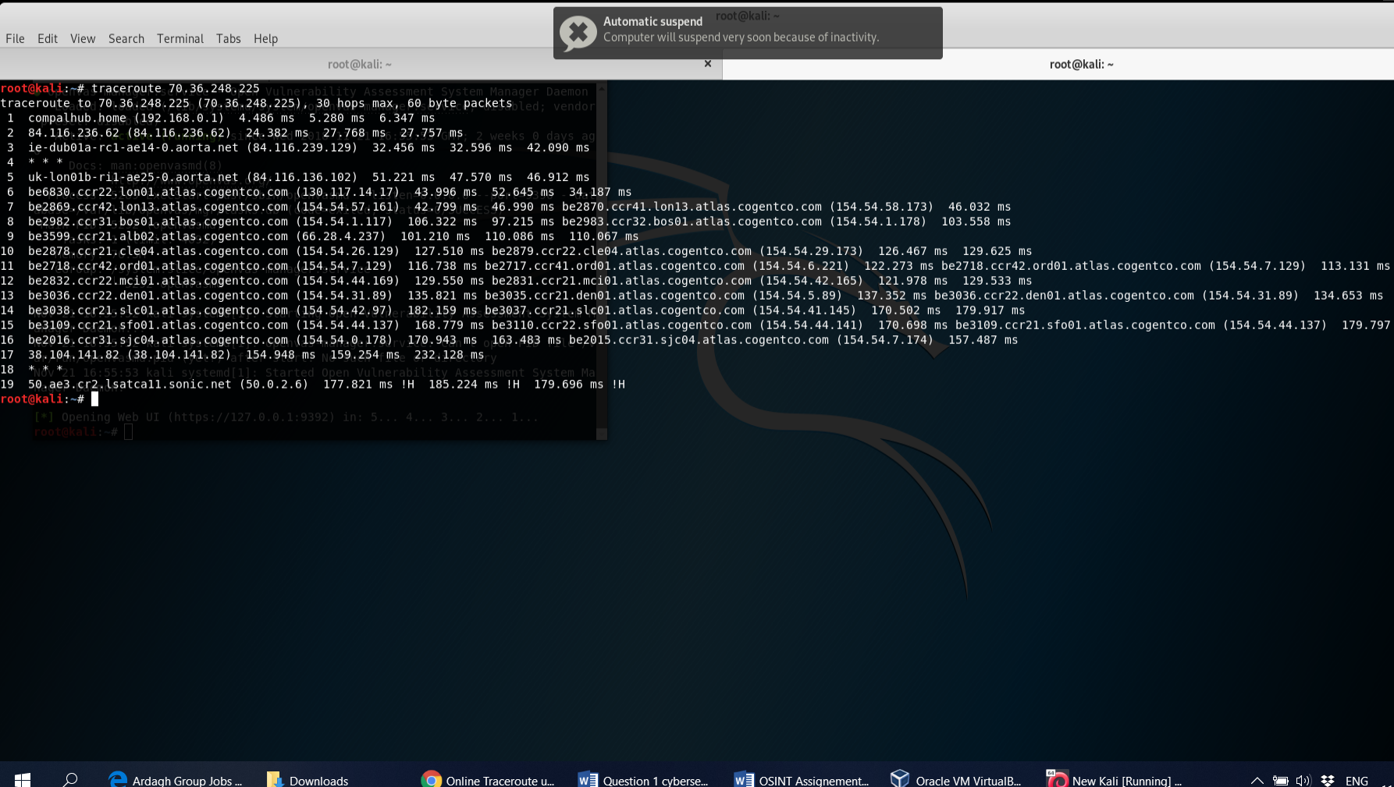

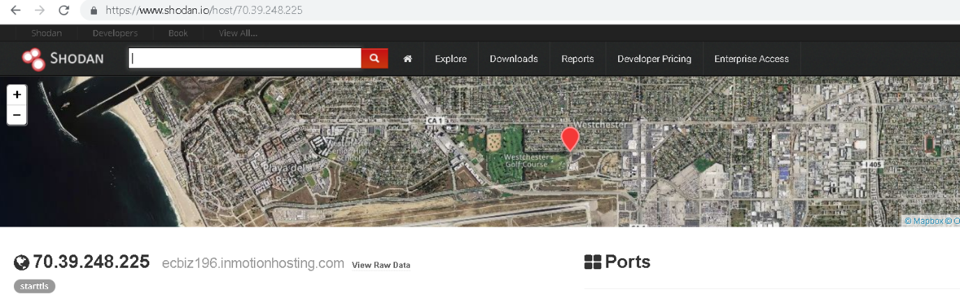

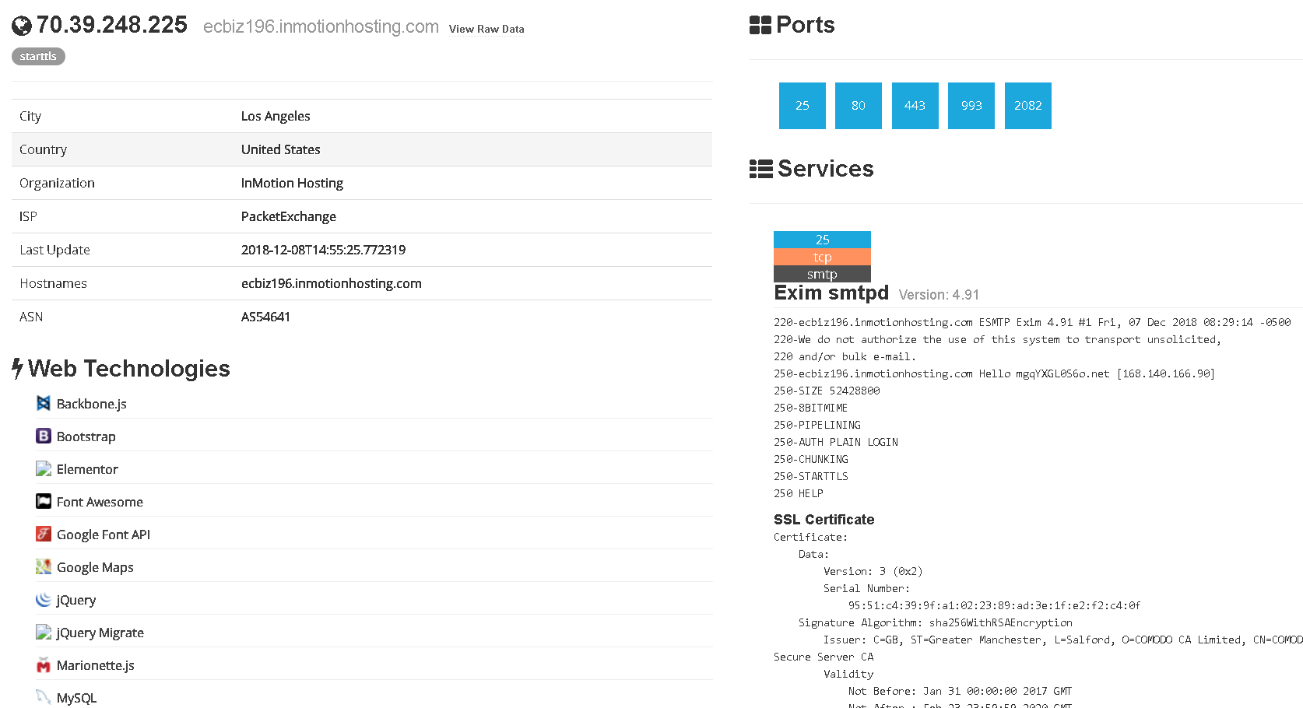

We can use Shodan, Whatismyip or Robtex to explore more about the target machine

For example country, hosting, internet service provider and more information. On the screen shot above we can see the data about the host on the left, the list of all open ports found at the top right and then individual port details and banners from each port.

Open ports are as follows: Simple Mail Transfer Protocol (25), Hypertext Transfer Protocol (80), Hypertext Transfer Protocol over TLS/SSL (443), Internet Message Access Protocol over TLS/SSL (993), cPanel (2082).These open ports and services running on these ports can be exploited to get into the webserver.

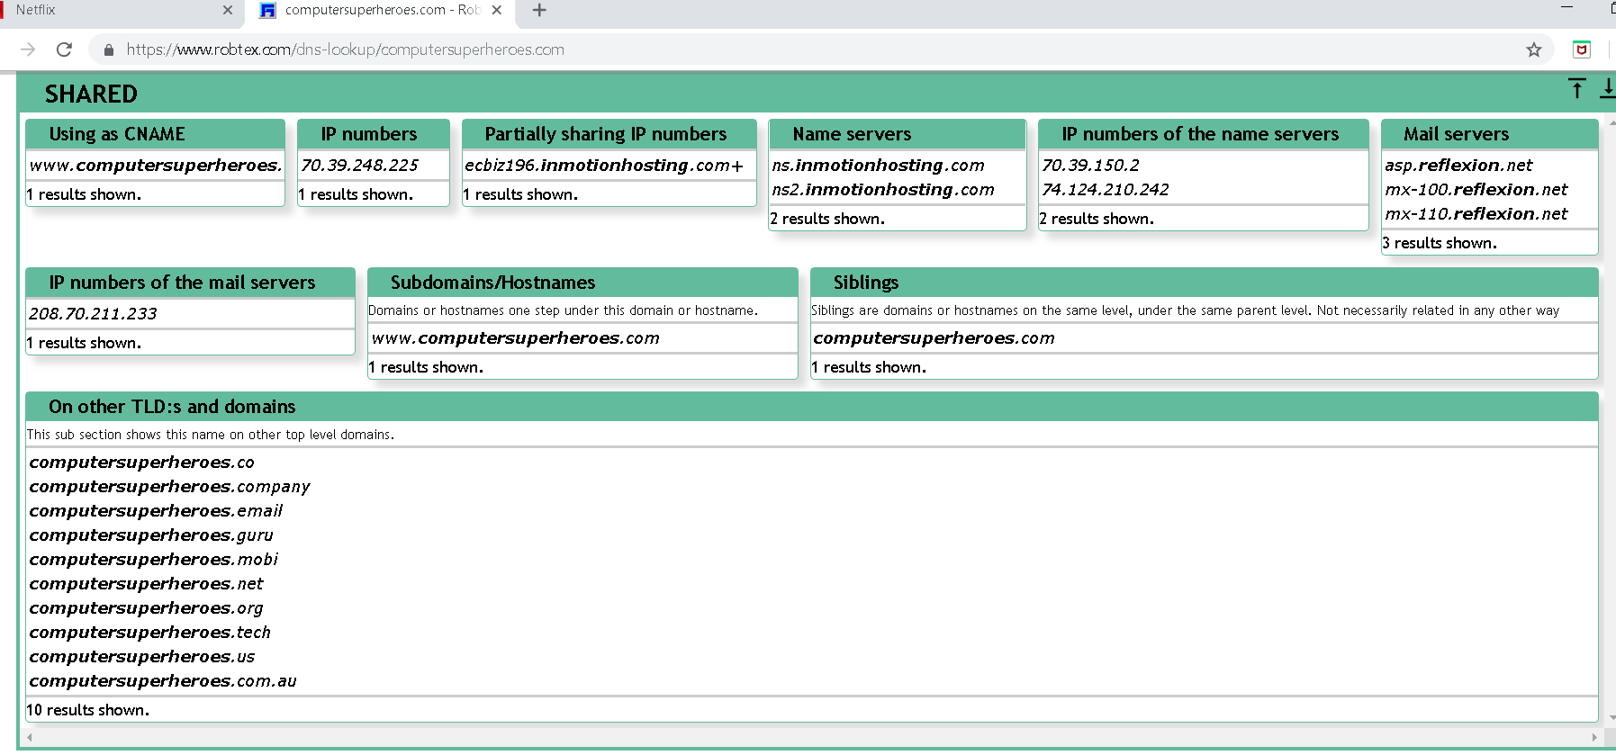

A mail server (mail transport agent or mail router) is an application that receives incoming e- mails from local users ( people within the same domain) and remote senders and forwards out going e-mail for delivery.

The domain Computersuperheroes.com also uses mail servers with different IPs. We have used Robtex to find those IPs. These IPs can be used to check the abuse status or blacklist check. The Mail Server IP is “208.70.211.233” as shown in the above screen shot.

Furthermore, Name server is a server on the internet specialized in handling queries regarding the location of a domain name’s various services. Nameservers are a fundamental part of the Domain Name Server. They allow using domains instead of IP addresses. We have used Robtex to find out the IPs of the nameserver used by the domain.

The IPs of the nameservers are “70.39.150.2, 74.124.210.242” as shown in the above screen shot. I didn’t put the screetshot because is a duplicate of the above.

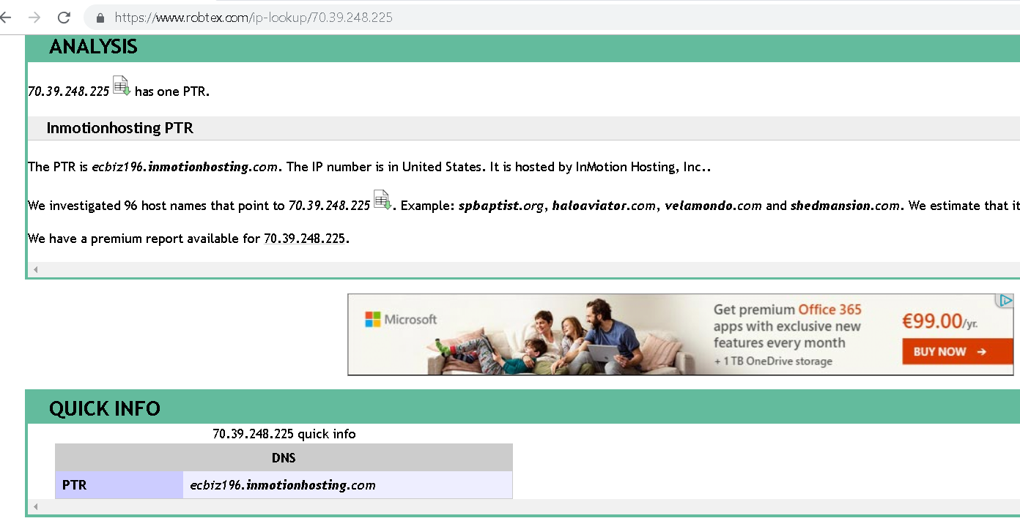

Robtex uses various sources to gather public information about IP address, Domain names, host names, autonomous systems, routes etc.

Robtex provide information such as:

Reverse DNS Lookup: Searches for an IP number and get which hostnames points to it. The reverse DNS lookup does not only works for IP but also mail server and name server records.

WHOIS: There you can find contact information from the domain registration together with the registration date and expiry date.

Using Robtex tool we can dig deeper and extract more information about the target.

A full Robtex result of the target can be found at this url: <https://www.robtex.com/ip-lookup/70.39.248.225> ( I think this is where my professor said I gave reference but no explanation!!!!

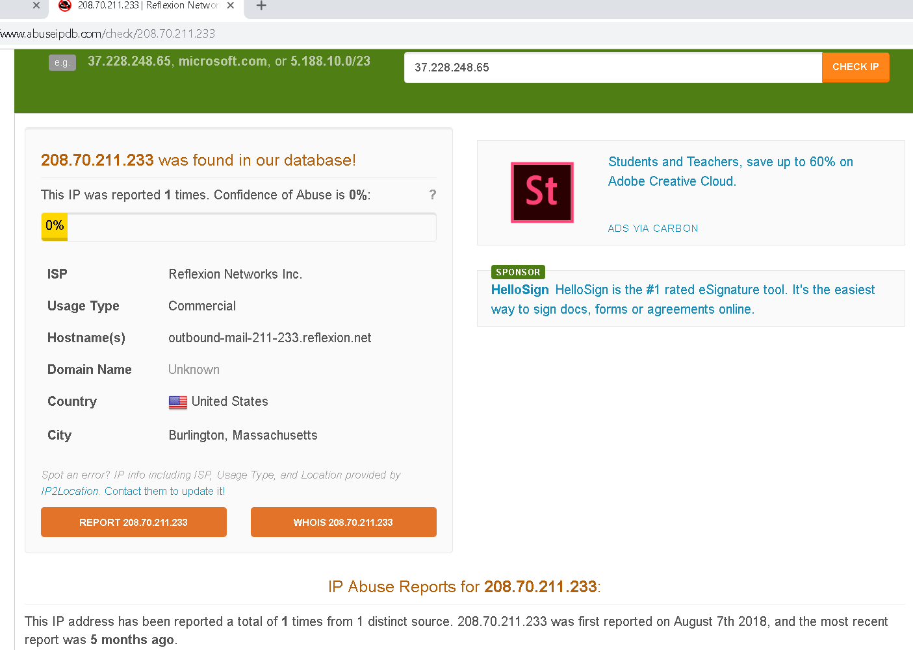

We have used Abuseipdb to find out any blacklist check as well as reporting history of the Mail Sever.

The screen shot above shows that the mentioned IP has been reported once from one distinct source. It was first reported in 07/08/2018. The most recent report was five months back. Their internet service provider is Reflexion Networks Inc and the IP is located in United States, city Burlington, Massachusette.

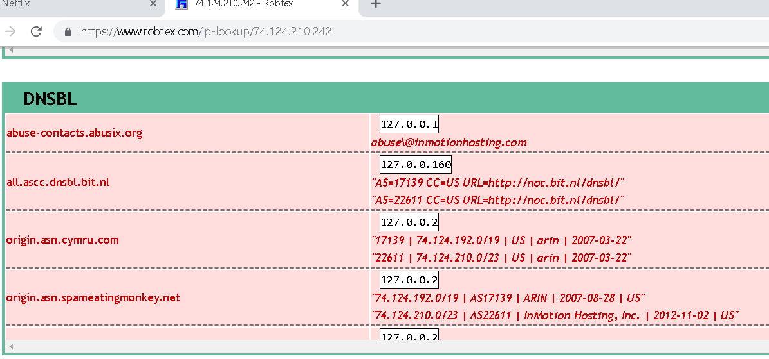

Domain Name Server Blacklists or DNS Blacklists, are spam blocking lists that allow a website administrator to block messages from specific systems that have a history of sending spam. The DNSBL screen shot above also shows that the nameserver IPs are listed in several DNS Blacklists.

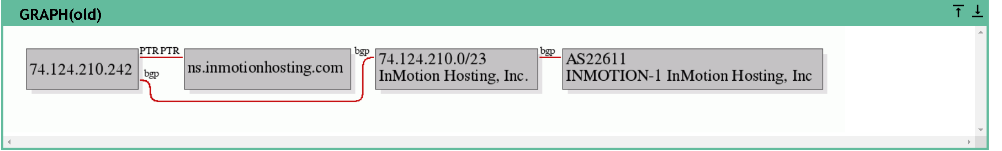

DNS Blacklists status of nameserver IP 70.39.150.2 ( Please explain this a little bit more based on the screen shot). You repeated the same DNSBL and Graph(old) with no explanation. Or is just a mistake I can’t really tell. Please correct that.

Web server information using Netcraft. The web server is “Apache” and is deployed on Linux operating system.

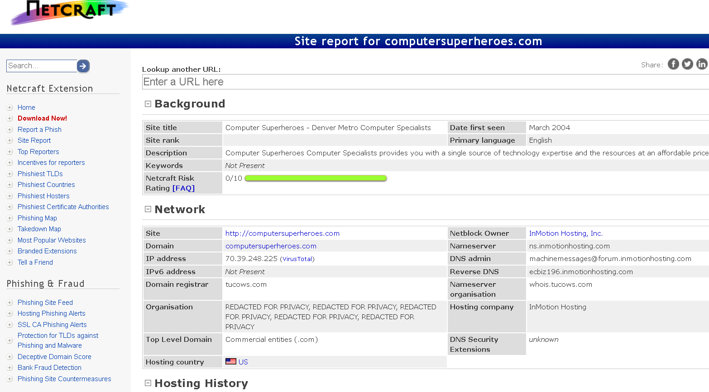

More detailed information can be found from this url: <https://toolbar.netcraft.com/site_report?url=computersuperheroes.com>

We can use MX ToolBox to check the blacklist status for Computersuperheroes.

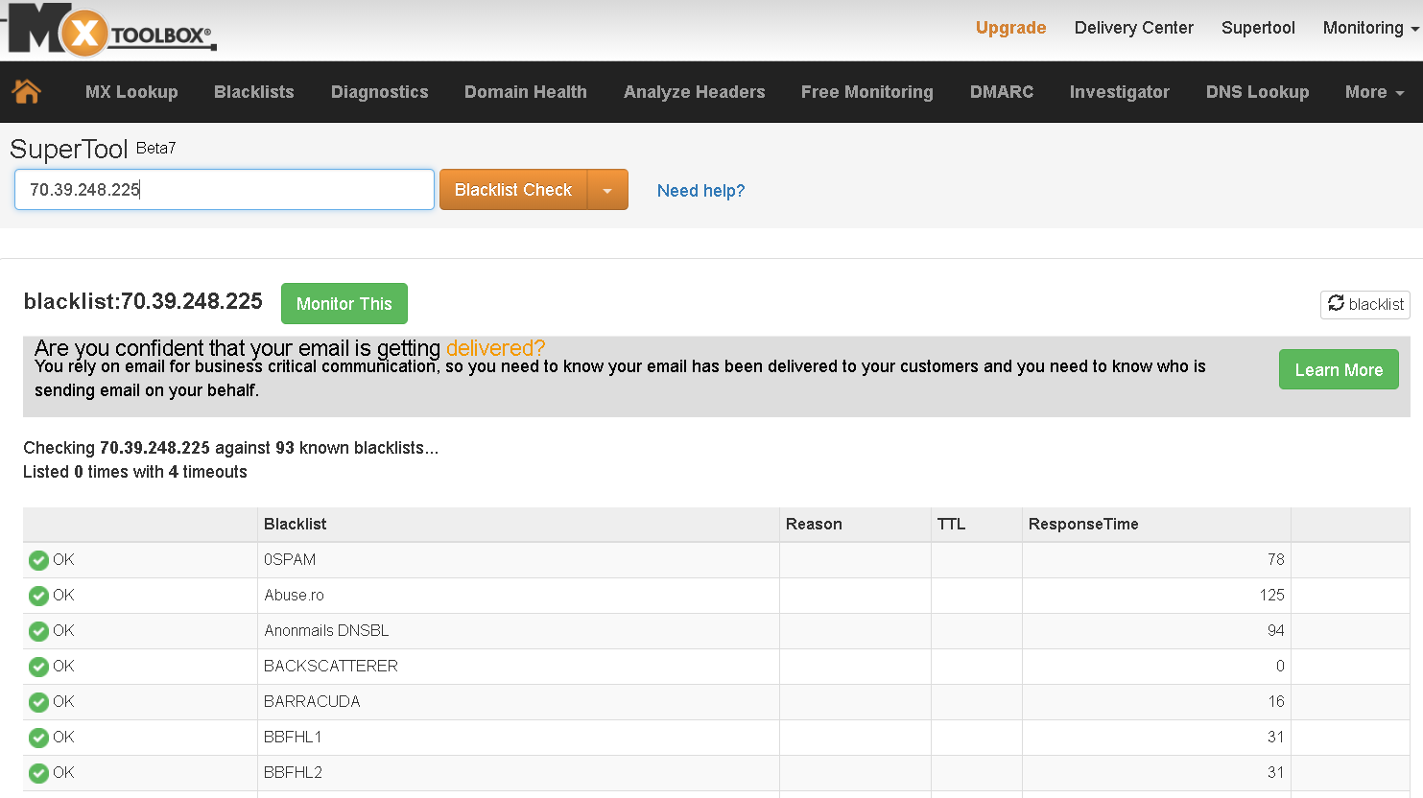

Put an explanation for the above screeshot

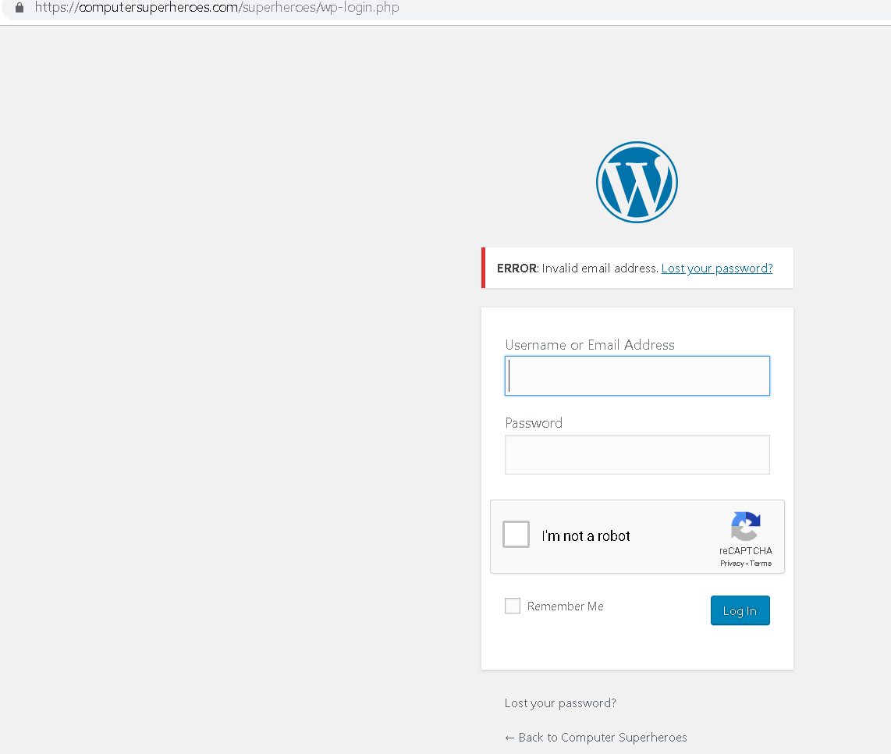

We have dig out entry points to the server and found the admin panel for Admin login. This means using brut-force password tools, we can launch an attack to get an entry to the server. The admin panel must not be visible to outside users as a best practice.

If we go into their website, we can see the client portal. This can also be used for an entry point to the server. See the snapshot below.

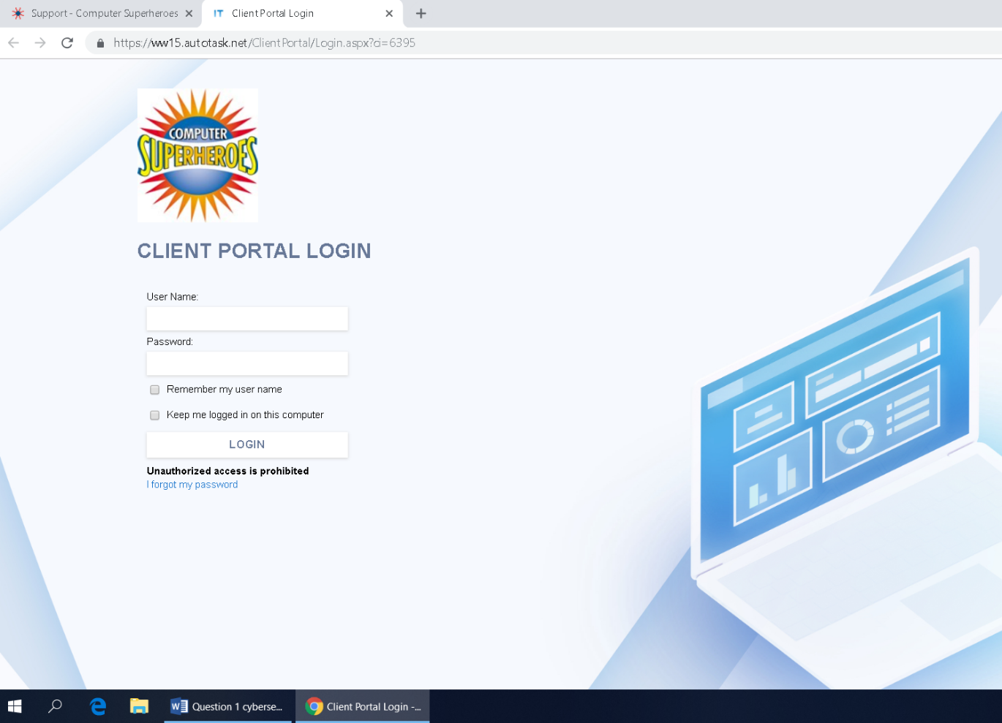

The technical announced jobs by an organisation can also be used for getting in depth knowledge of the internal IT infrastructure as well as the skills of their technical workforce. We have tried to search for technical jobs announced by the company computer superheroes. We found many interesting things like are using Virtualization platform Hyper V, Windows Server, Active Directory, LabTech and other softwares.

Using this information a specific attack can be launched against the organisation using known weakness software/hardware and its exploit.

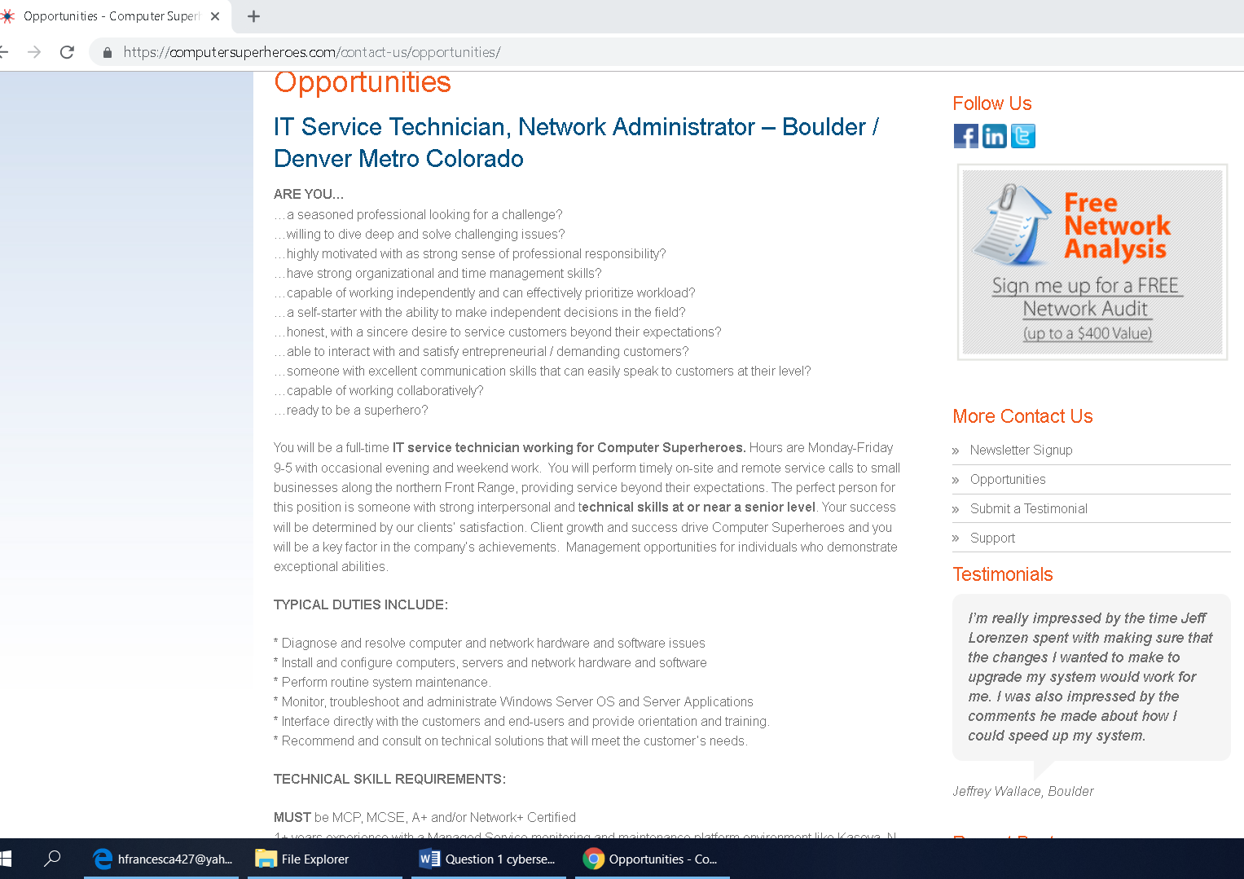

Searching on different platforms like Google and LinkedIn, we found some of the employees working in the company, their skills and interests.

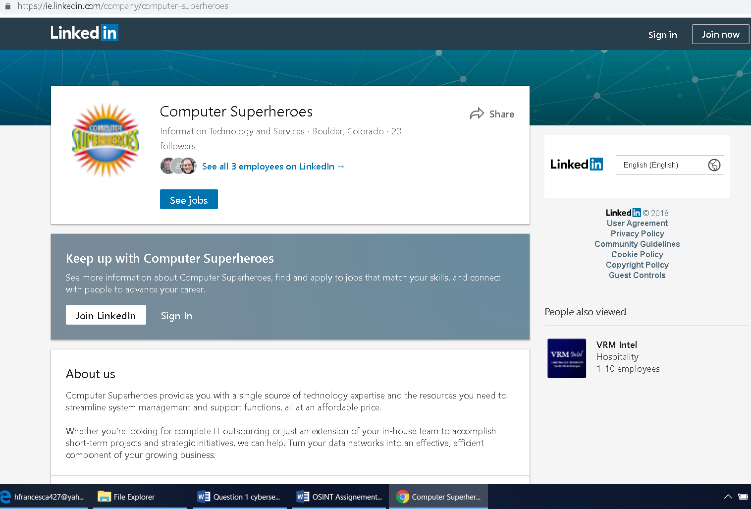

Travis McCord is a Technician at Computersuperheores.

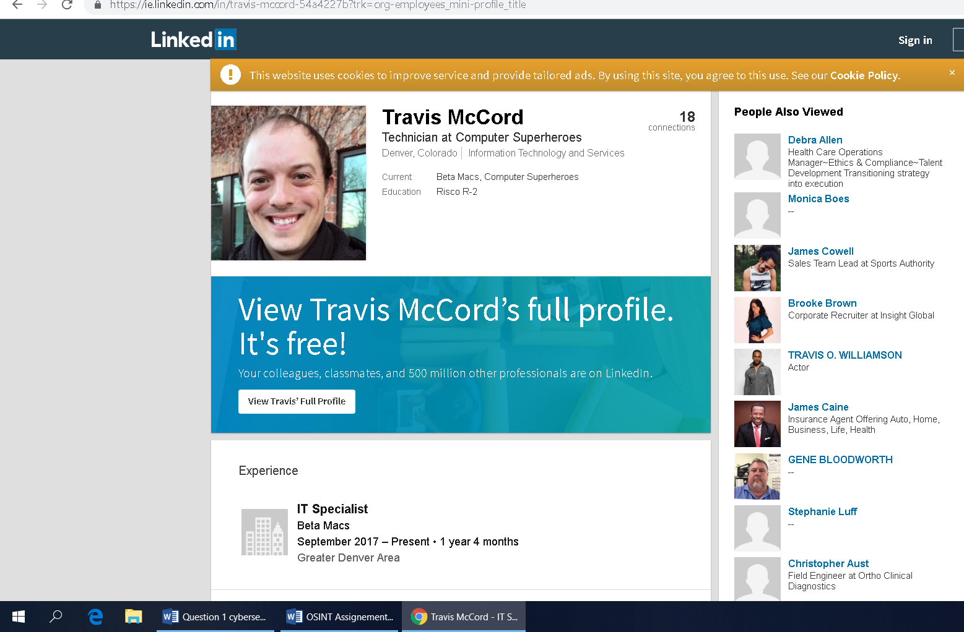

Jeff Lorenzen is the CEO of the company. These accounts and details can be used for phishing or some kind of attack.

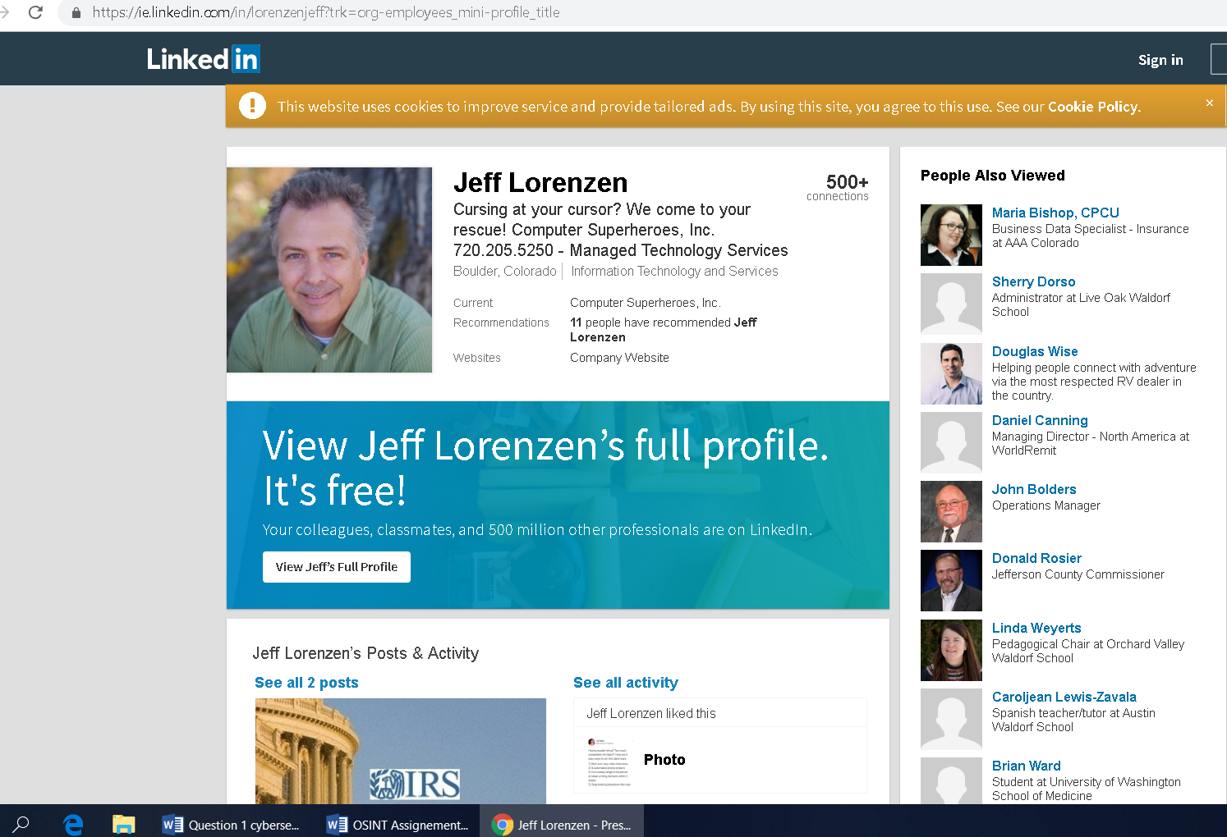

Austin Clark work as a Tech support engineer.

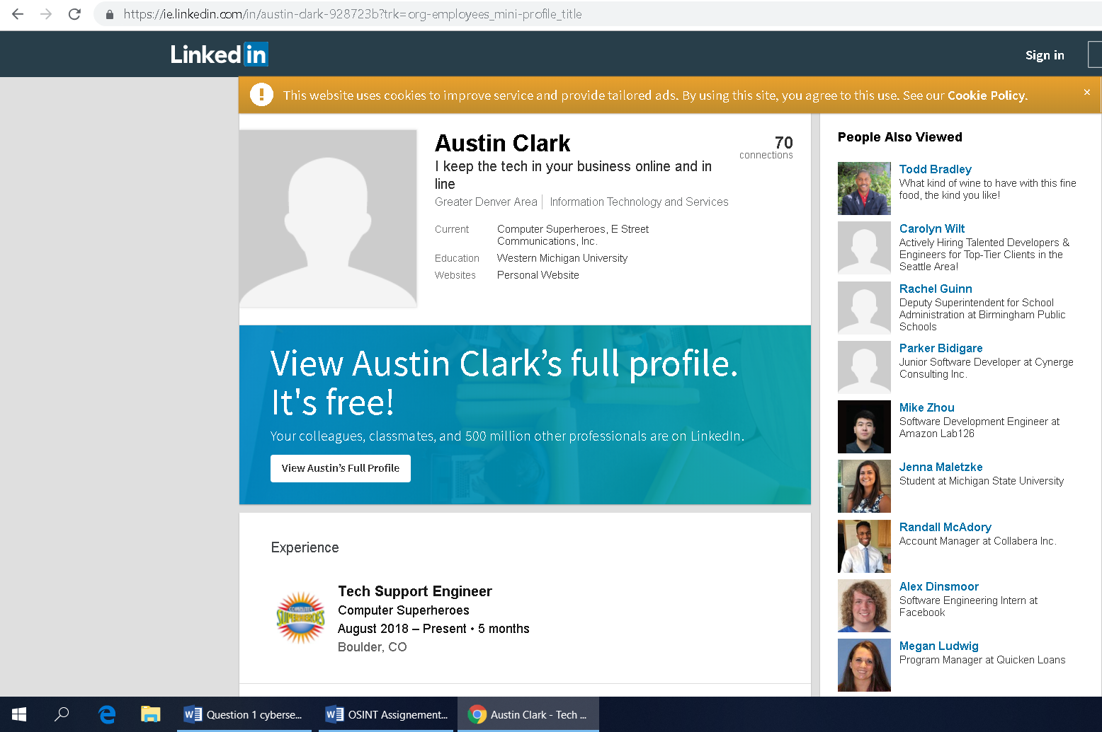

Using the BrowserSPY Tool, we can get a lot more information about the tartget without directly engaging with the target. This is the part my professor gave ffedback saying tool referenced but no explation, please refer to feedback

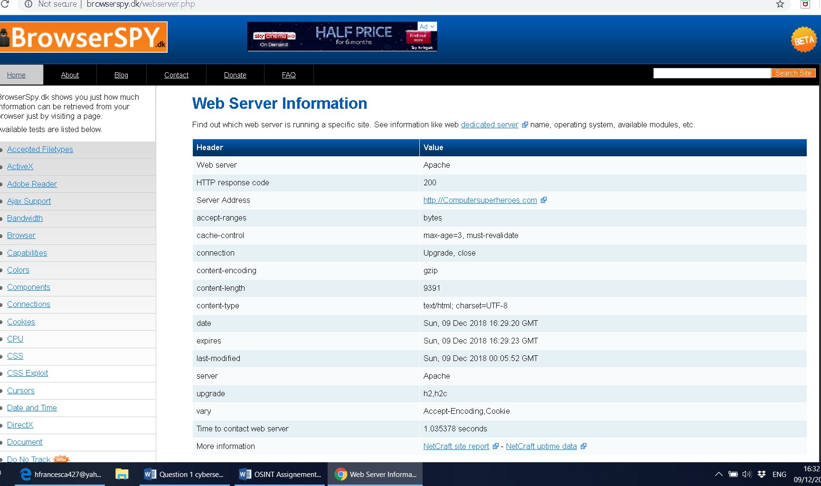

TARGET 2: <https://www.ardaghgroup.com>

Using Ping tool in Kali Linux to get the IP address of the target domain.

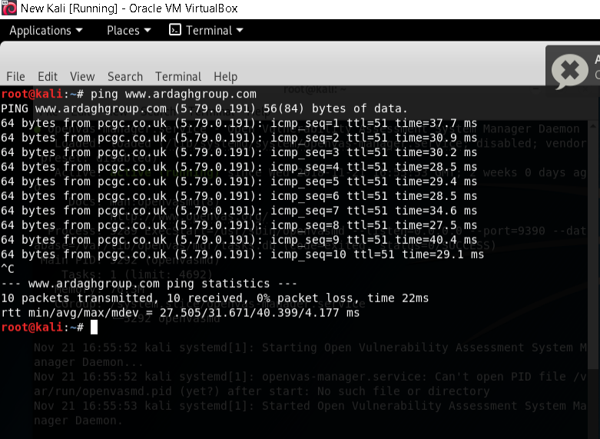

The IP of our target is 5.79.0.191. We can then trace route for routing and location information.

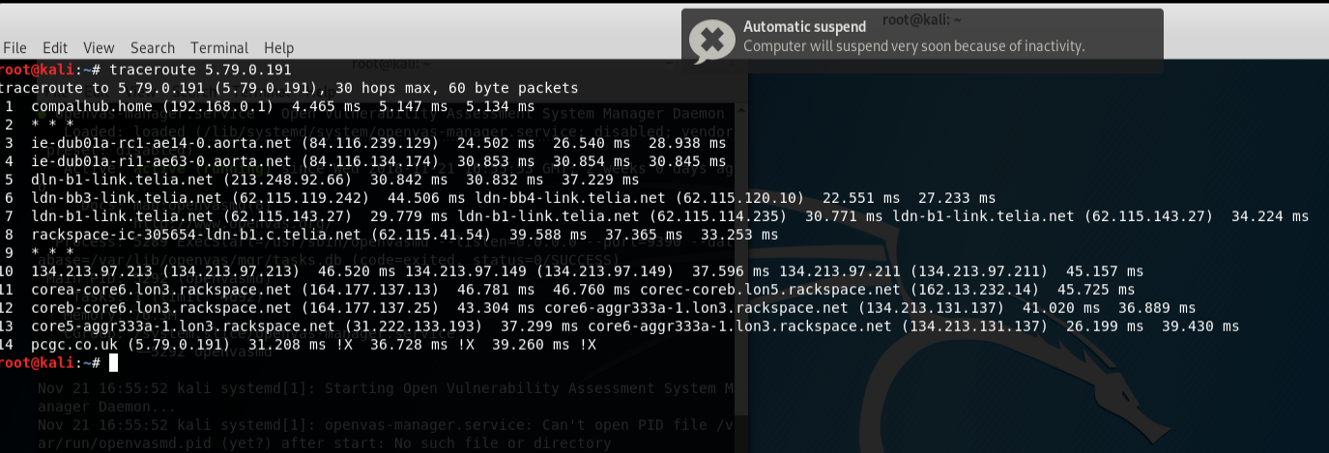

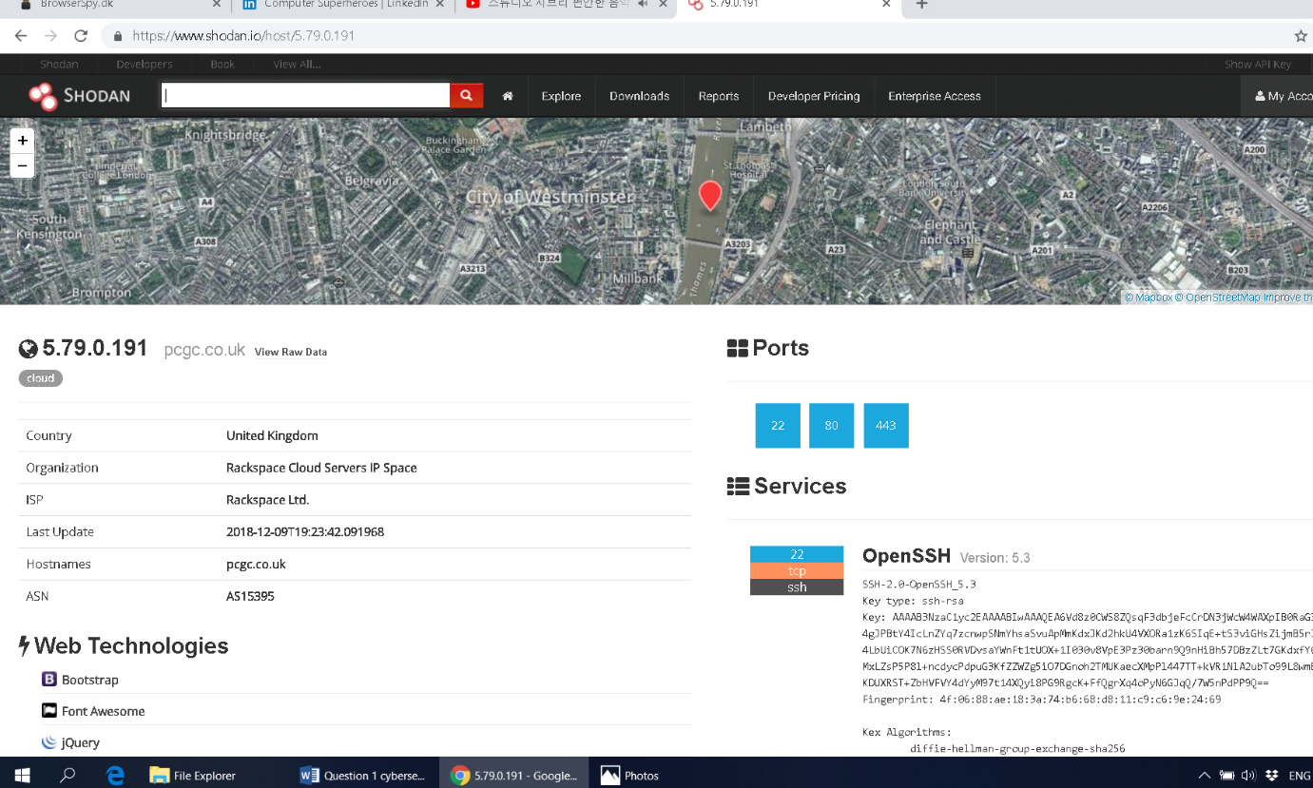

The target web server is using the following open ports 22,80 and 443. This means they are less exposed when compared to Computersuperheroes which had more open ports. We can see where the company is based, their Internet Service provider and services.

More information can be found here: <https://www.shodan.io/host/5.79.0.191>. See if we can explain a bit more from that link. My professor does not want links he want explanations he is very strict on that when he is marking.

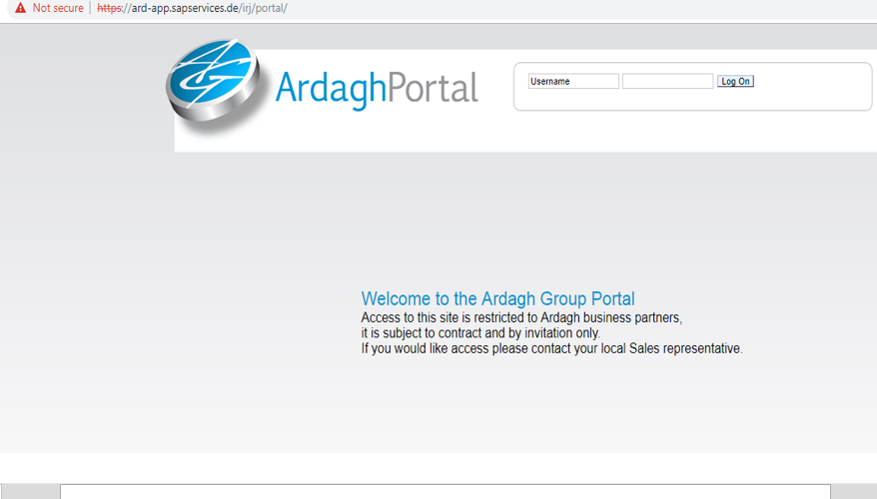

Customer login of Ardagh Group

We often use an insecure internet connection to browse the web or sending information such as credentials etc. The server if is configured to communicate using an insecure protocol like HTTP, this exposes us to man in the middle attacks with malicious attackers trying to steal our login information, passwords and other sensitive information.

The customer login portal for Ardagh Group have no Secure Sockets Layer/ Transport Layer Security certificate installed for secure sending users credentials as shown in the above screen shot. Man in the middle attack (MiTM) can be launched to sniff the customers credentials.

There is an easy solution to this problem where by, when sending sensitive information a website should always use a secure protocol such as HTTPS. In this way, attackers listings to the community only see encrypted information they cannot decrypt. You know that your communication is secure when the website address starts with “https” and your browser displays a lock icon and additional user interface cues.

When using Transport Layer Security you can be confident that no one has read your messages, no one has changed your messages, you are communicating with the intended server(person).

Mail Server of Ardagh Group

A mail server also known as mail router is an application that receives incoming e-mail from local users (people within the same domain) and remote senders and forwarding out going e-mail for delivery.

The domain ardaghgroup.com uses mail servers with different IPs. We have used Robtex to find those IPs. These IPs can be used to check the abuse status or any blacklist check.

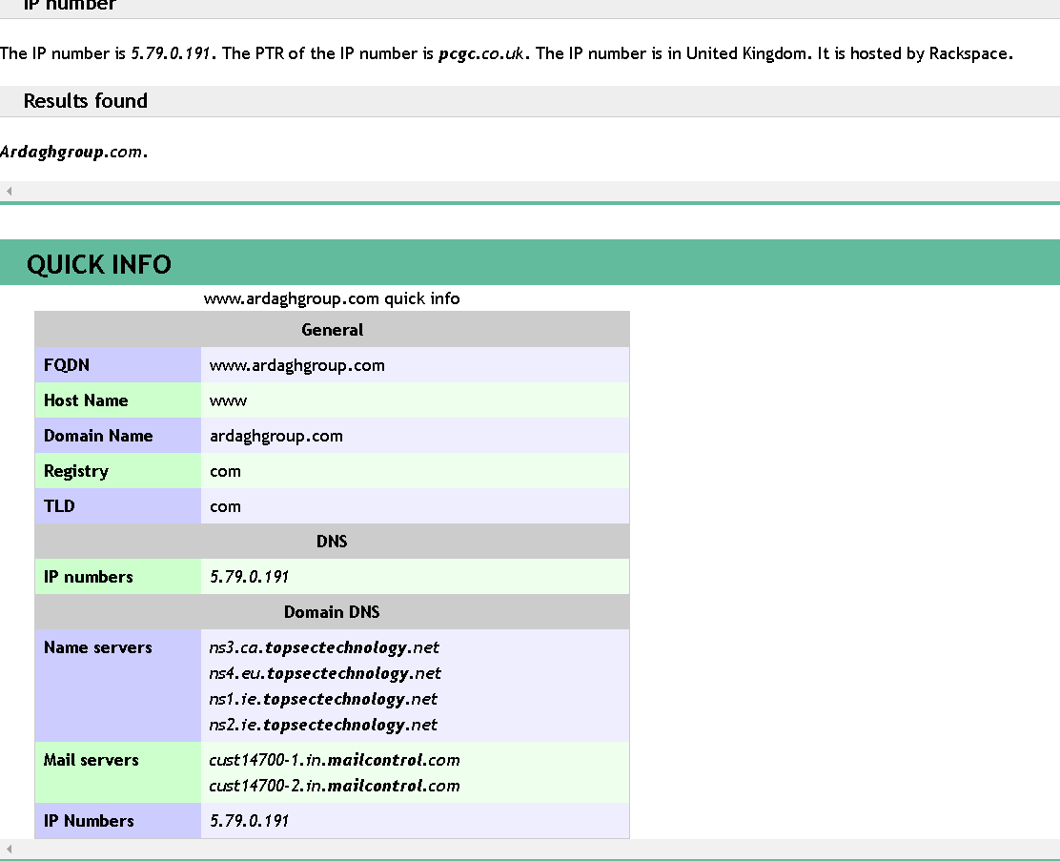

The IP number is in the United Kingdom, hosted by Rackspace. The Mail Server IPs are “85.115.52.190, 85.115.52.190” where did you get this mail server ips I can’t see them in this screenshot.

Please add more information you think is relevant.

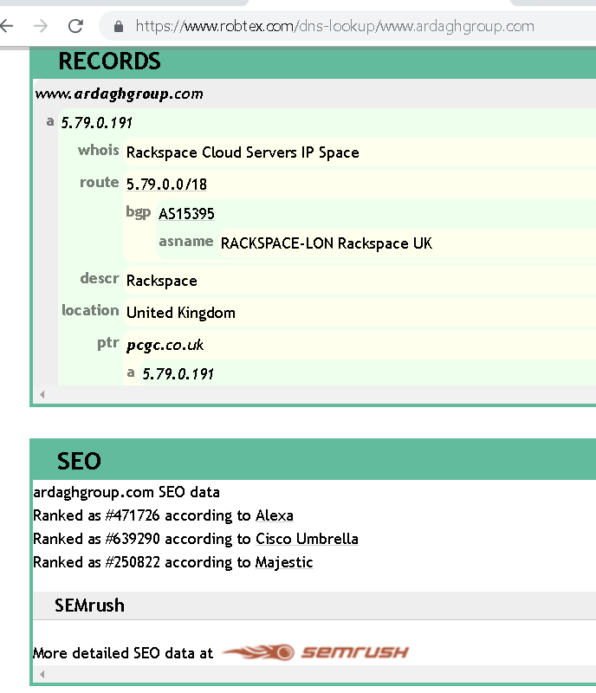

Please lets put relevant explanation here as it is very important

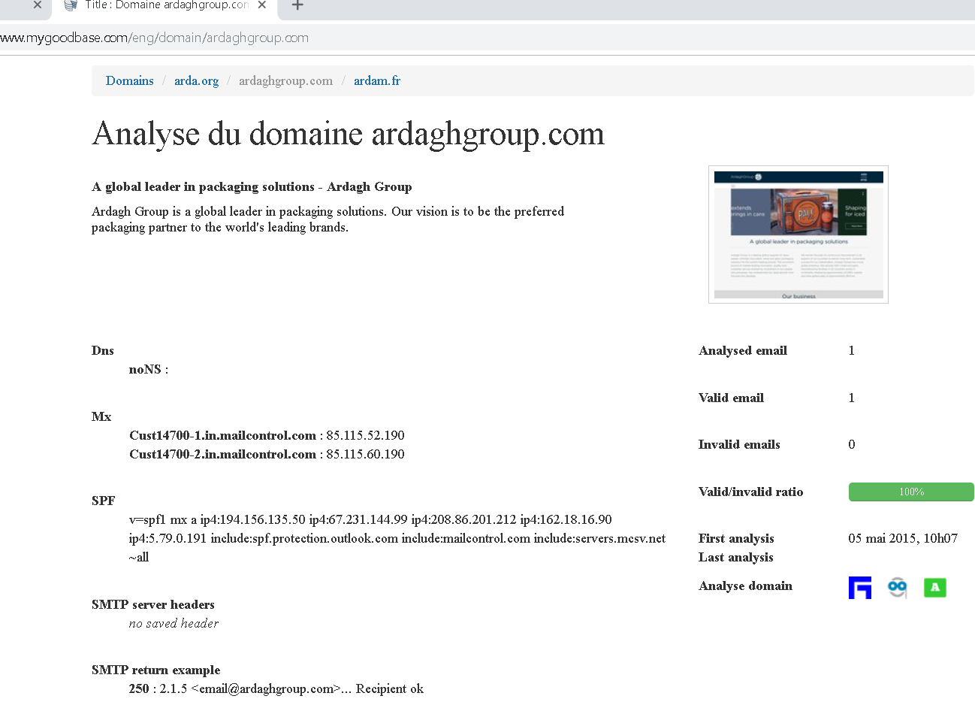

The above IPs can be confirmed from “mygoodbase.com” and Domain testing. Lets add more information on what did we get/ can we see from the above screen shot. That’ s what my professor is interested in “ EXPLANATION”

Listing in Abuse List

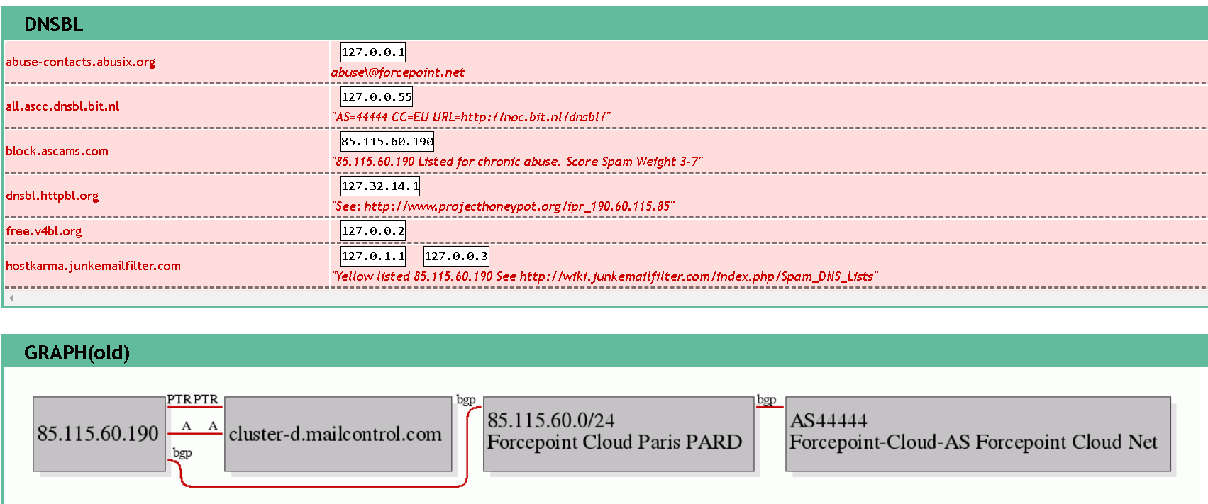

Domain Name System Blacklists (DNSBL) are spam blocking lists that allow a website administrator to block messages from specific systems that have a history of sending spam. The screen shop above shows that the mail server IPs are listed in several DNS Black lists.( please give examples what type of blacklists are listed )

DNSBL information provides a single place where you can check that blacklist status of your mail server’s IP address , on more than 100 Domain Name System(DNS )based blacklists. Status of the IP address 85.115.60.190 (please elaborate more the status of the IP what its status mean for example, also for computersuperheores ) that is what do you mean when you say “status of IP address 85.115.60.190

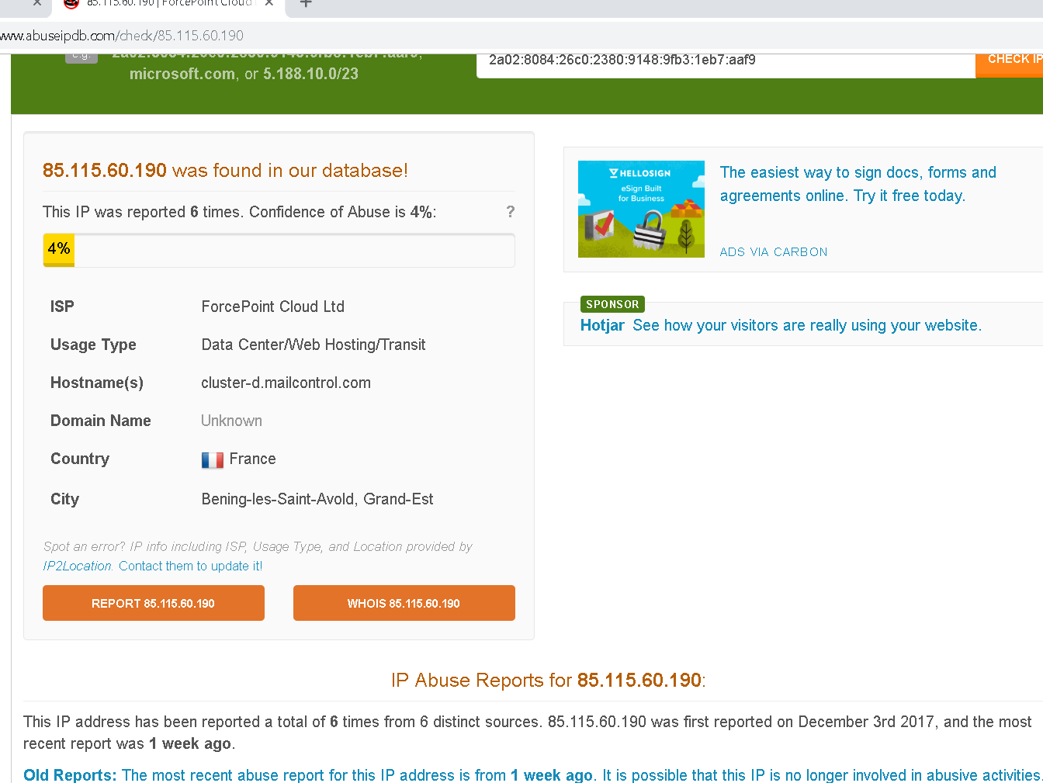

We have used Abuseipdb to find out any blacklist check and reporting history of the Mail server. The above screen shot shows that the mentioned IP has been reported 6 times from six distinct sources. It was first reported on 03/12/2017 and the most recent report was one week ago.

It is possible that this IP is no longer involved in abusive activities .



Status of IP: 85.115.52.190 from abuseipdb.com please explain more to support this, what do you mean status of the IP :85.115.52.190 I also don’t understand

I can see that IP 85.115.52.190 we are referring to it in many occasions I am not sure where is this IP coming from. I think I have already asked the same question somewhere

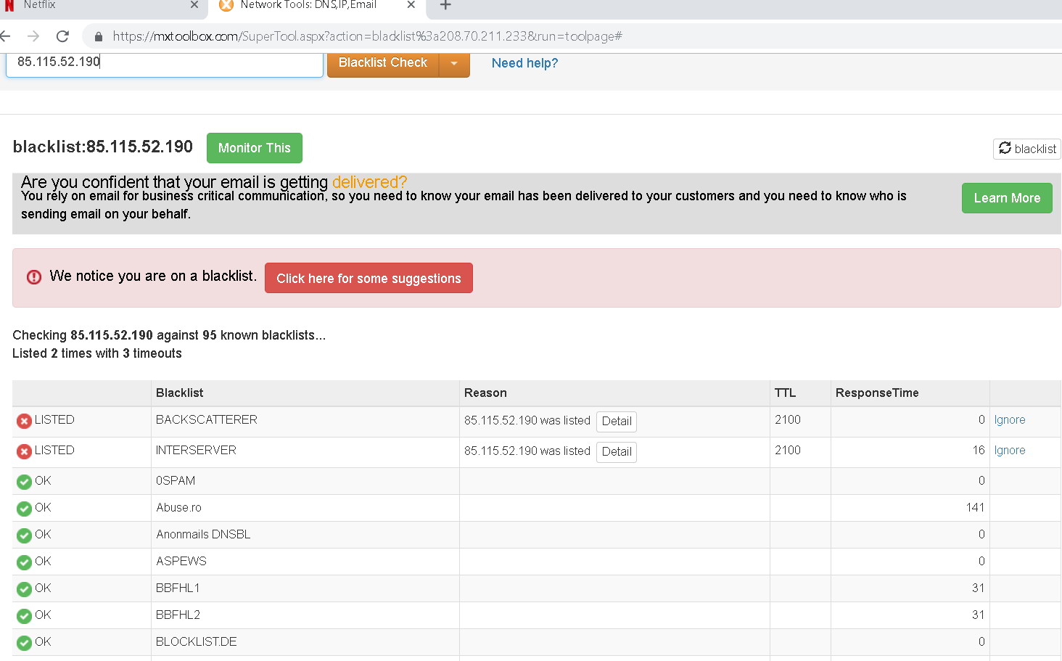

Blacklist status of IP 85.115.52.190 from mxtoolbox.com. MxToolbox supports global internet operations by providing free, fast and accurate network diagnostic and lookup tools.

The screen shot above indicate that the IP is listed in two blacklists that is BACKSCATTERER and INTERSERVER.

Listing on Backscatterer blacklist indicates that the mail server is issuing “backscatter” in the form of non -delivery reports to external users.

The InterServer DNS-based Blackhole list is a spam trap DNSBL. This list does not take spam reports from third-parties. All blocking is done based on email received to their multiple spam trap email addresses through their network. SOMETHING LIKE THIS I FIND IT VERY WELL EXPLAIED

Blacklist status of IP: 85.115.60.190 using mxtoolbox.com

Maybe add a line to explain what its status mean. It is a duplicate of the above then lets remove the screen shot.

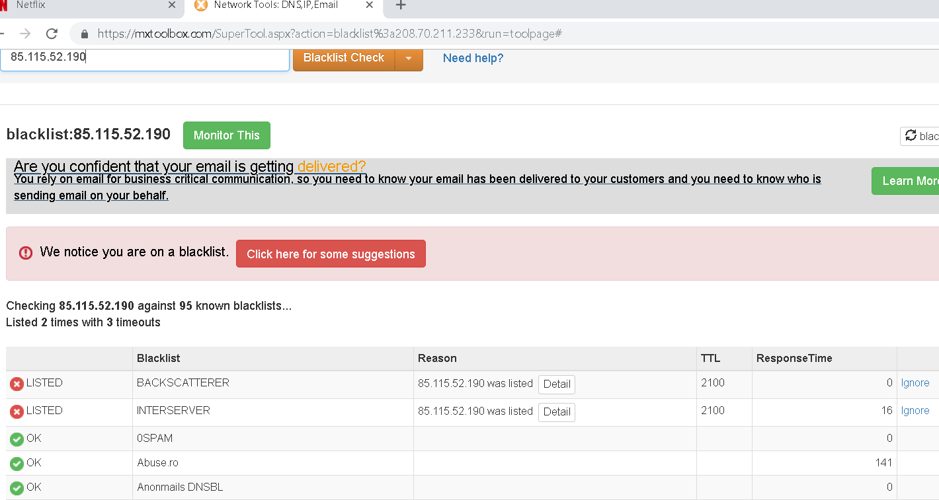

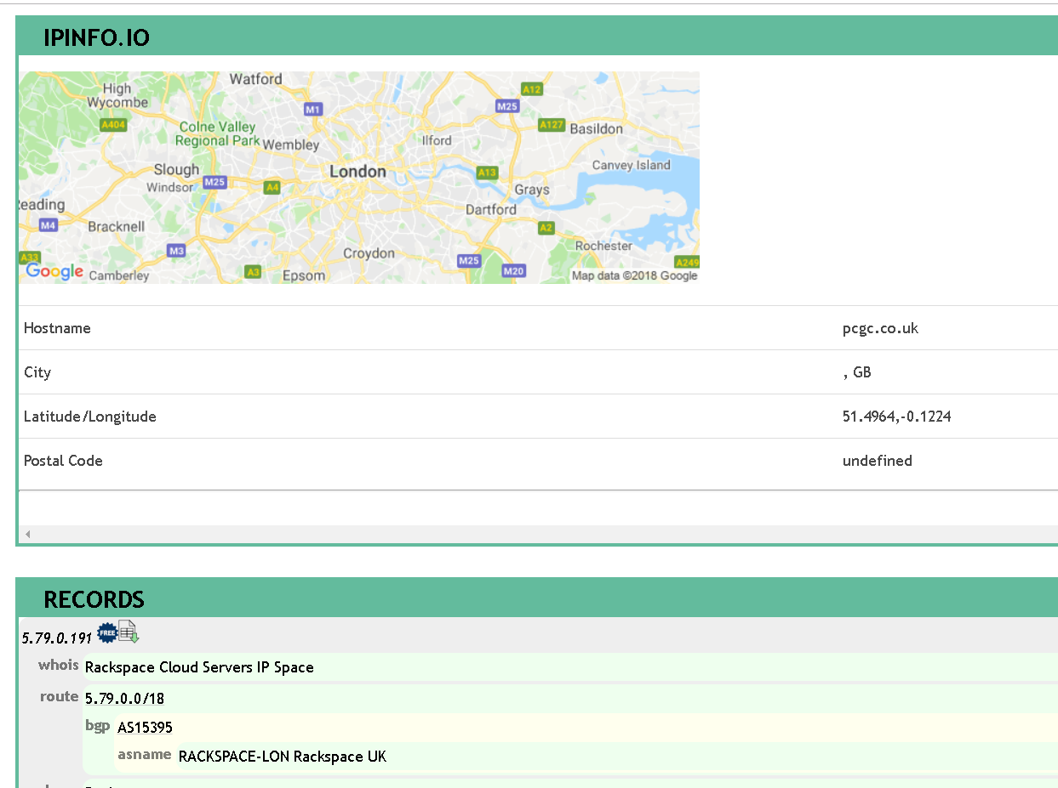

We can see that the company’s host name is pcgc.co.uk and in Great Britain city. More information can be found here: <https://www.robtex.com/ip-lookup/5.79.0.191> also here please

PLEASE THIS NETCRAFT INFORMATION CHECK IF WE DON’T HAVE A DUPLICATE USING A DIFFERENT TOOL, IT LOOKS LIKE WE HAVE THIS INFORMATION ALREADY

Using Netcraft we can get detailed information about the web server and the deployed Operating System. The company is using Apache as a webserver and deployed on Unix operating system.

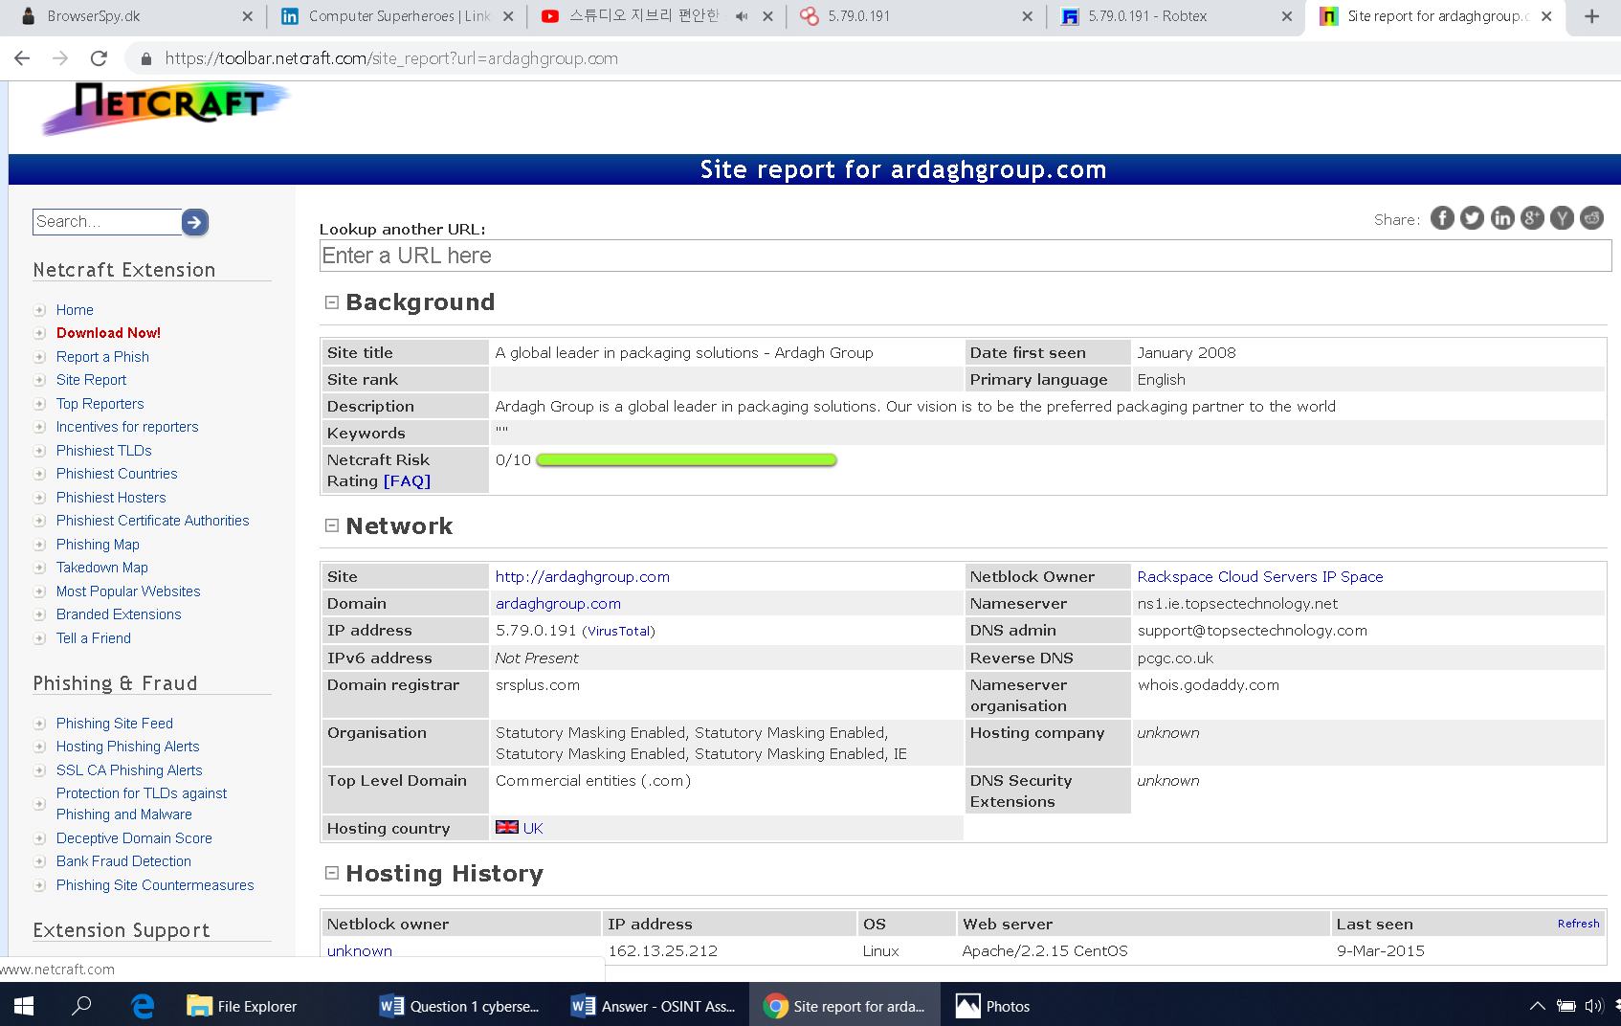

More information : <https://toolbar.netcraft.com/site_report?url=ardaghgroup.com>

The company is not among the black listed. That means they are not engaged in any form of abuse. Check if we are not repeating information related to MxToolBox sowhere.

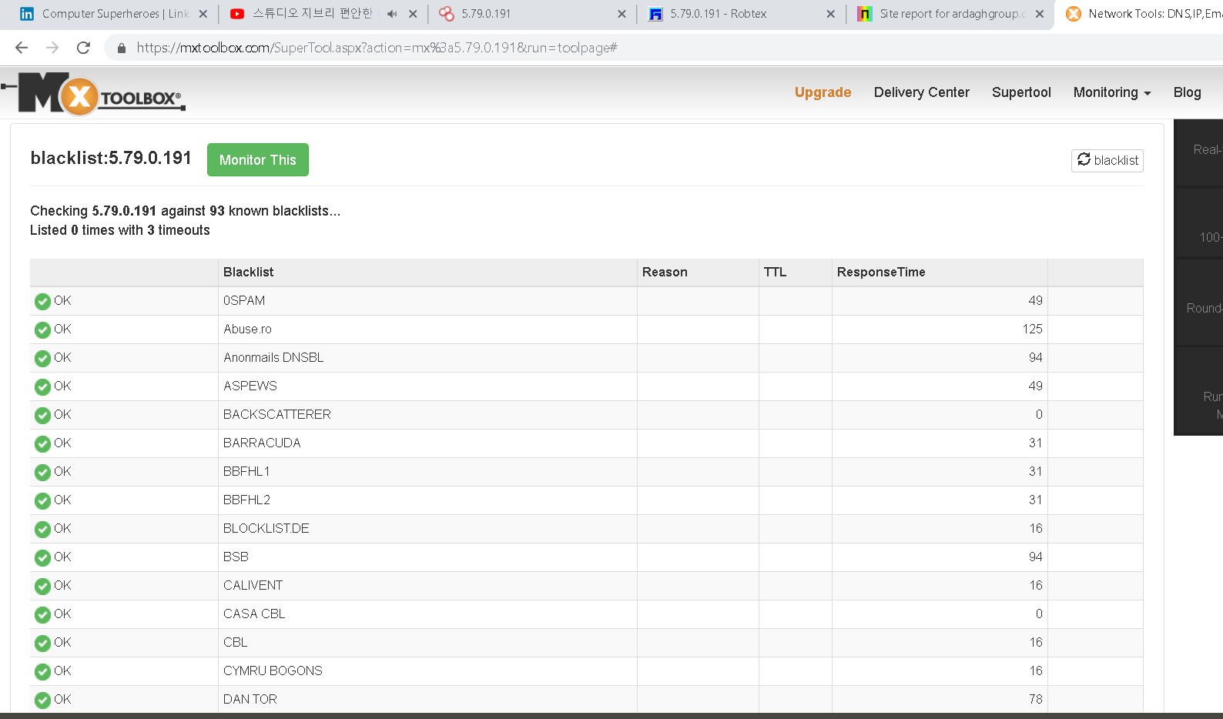

The Contact Us form can be used as an entry point to the web server and attacks can also be launched from this page.

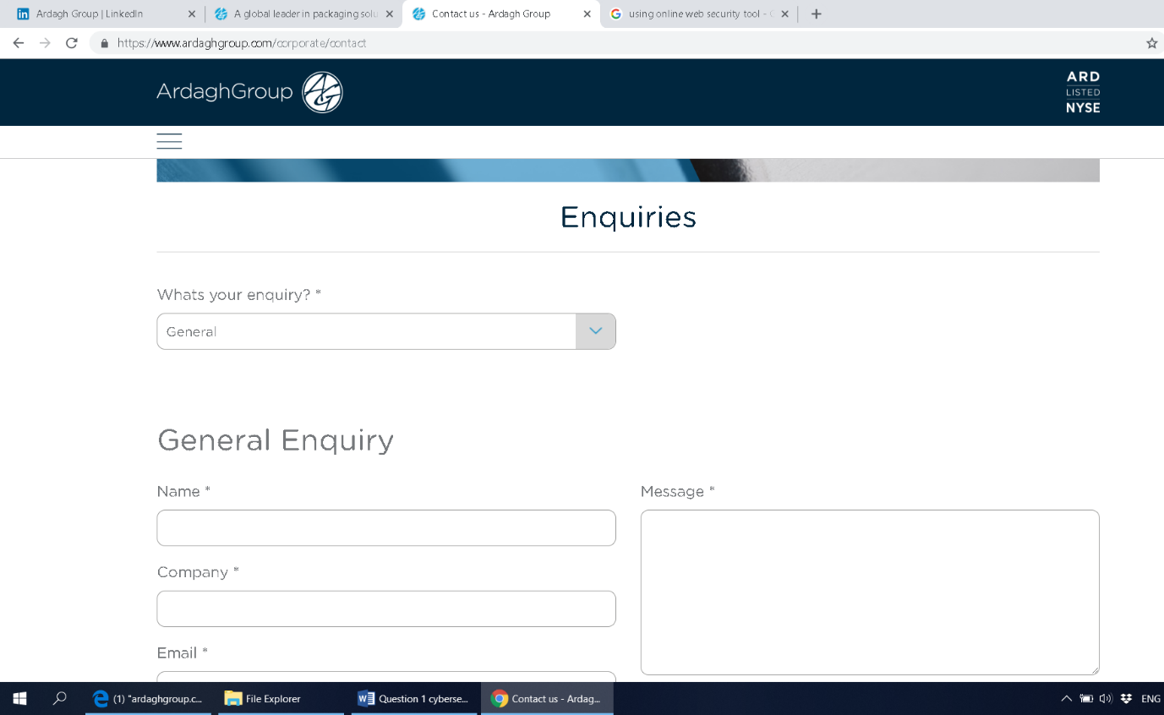

Employees related to Ardagh Group

Social engineering is still one of the most powerful tools in cyber-attackers, according to a report by a security firm “Positive Technologies” on how the human factor puts enterprises at risk. Employees download malicious files, click phishing links, correspond with hackers and even share contact information with their colleagues. It is the act of using any method conceivable to convince an employee to give up passwords, computer access or admitting to offer limits areas that a social engineer can use to steal sensitive data or access the systems.

Email social engineering(email phishing) is extremely the successful electronic social engineering. Legitimate looking phishing emails secretly contains malware or links to fraudulent web pages and are sent to employees with hopes of being opened. Google and LinkedIn are phisher’s best friends when researching trusted employee management and business partners to add legitimacy to their emails.

We have searched for employees of Ardagh Group from LinkedIn and other sources and found several employees of our interest.

David Whelan works as a Group IT Director Information Security at Ardagh Group. From his profile we can we can tell his background, his education, employment history, experience and expertise and the projects he have worked on. He have expertise in SIEM, Firewalls and Network Security. This information can be used to make social Engineering phishing attack.

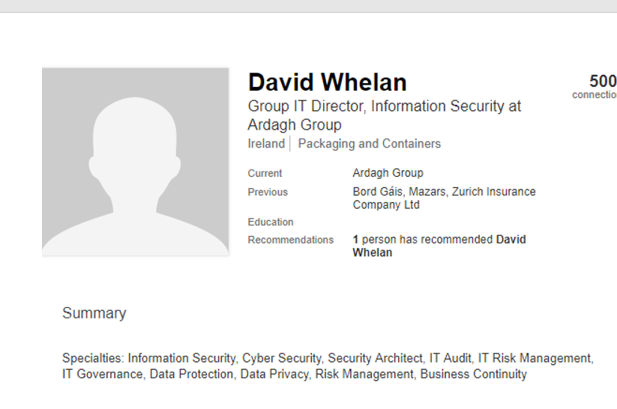

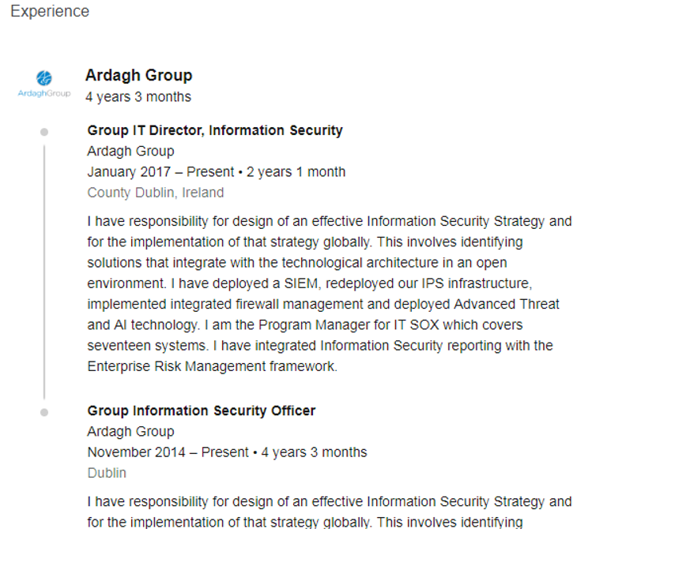

Below is a screen shot showing John Hampson profile. He is the Chief Information Officer at Ardagh Group.

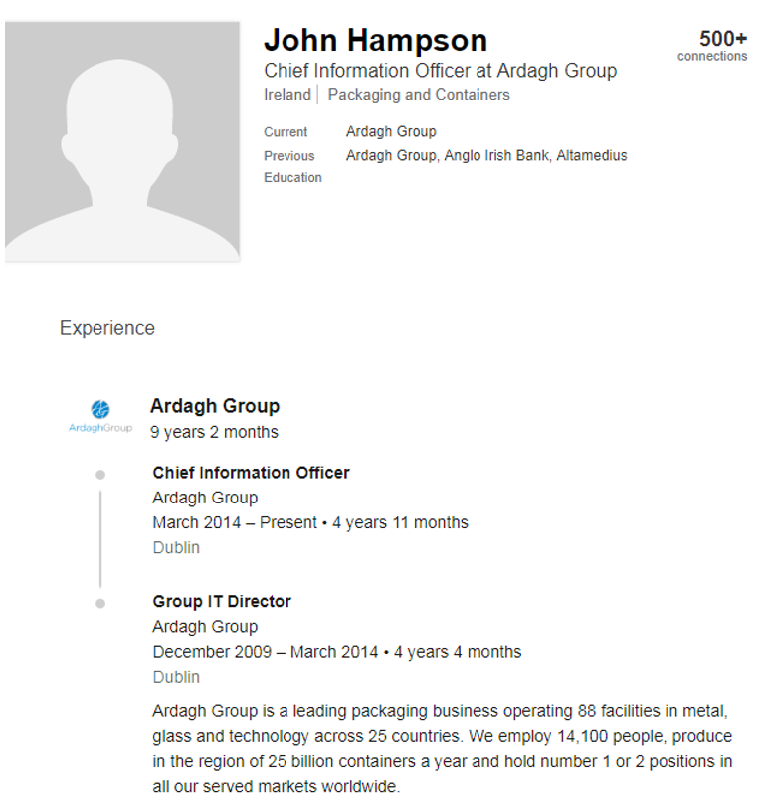

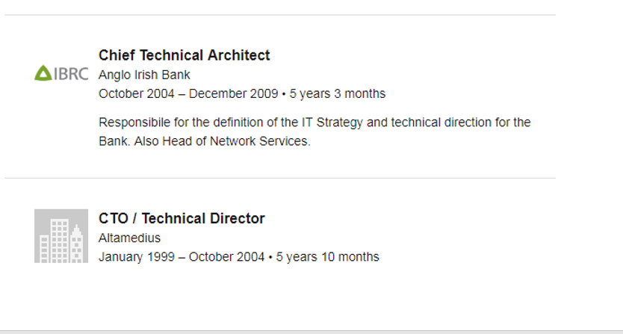

The below screen shot was taken from rocketreach.co. This OSINT tool also give us brief information about certain people.

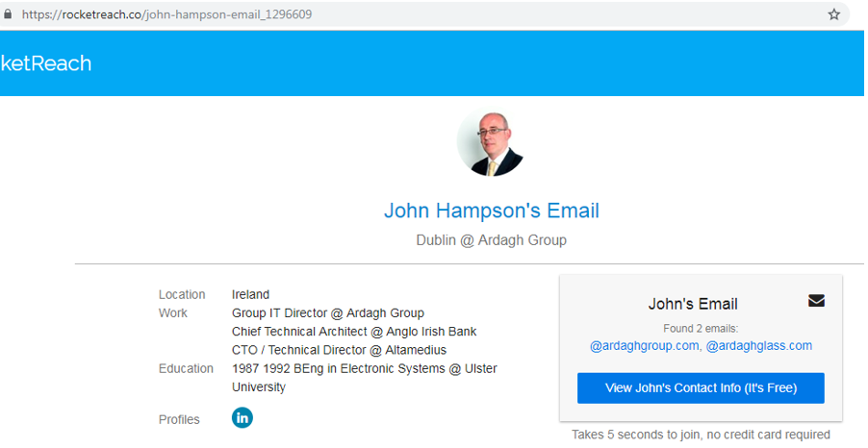

We have also searched for Ardagh Group IT infrastructure information. From a news blog Siliconrepublic.com we have discovered that the Company have invested 1 million Euros in a new HP networking rollout that will develop IT infrastructure for them as revealed in the screen shot below.



The following screen shot about the employee profile ( Emma Flannery), This information can be used for Social engineering attack.



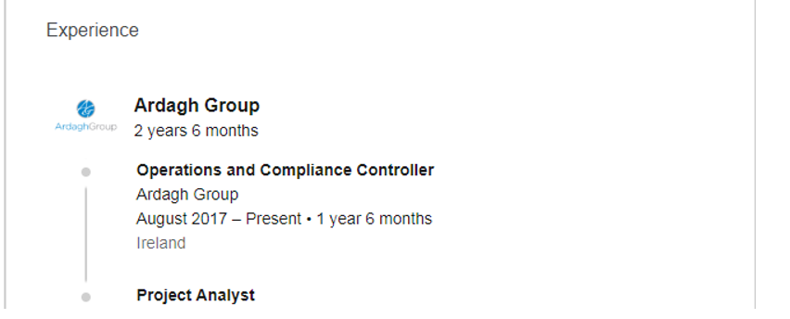

Below is Jeff Shonkwiler’s profile who is a Tax Director at Ardagh Group. We have searched more information about the Tax Director. We found the “APTC MEMBERSHIP MEETING” document. We also found Jeff’s email address. We can extract more information from the APTC MEMBERSHIP document as well. Mr Jeff can be easily be social engineered from the information presented in the document. For example spoofing someone’s email from the document.

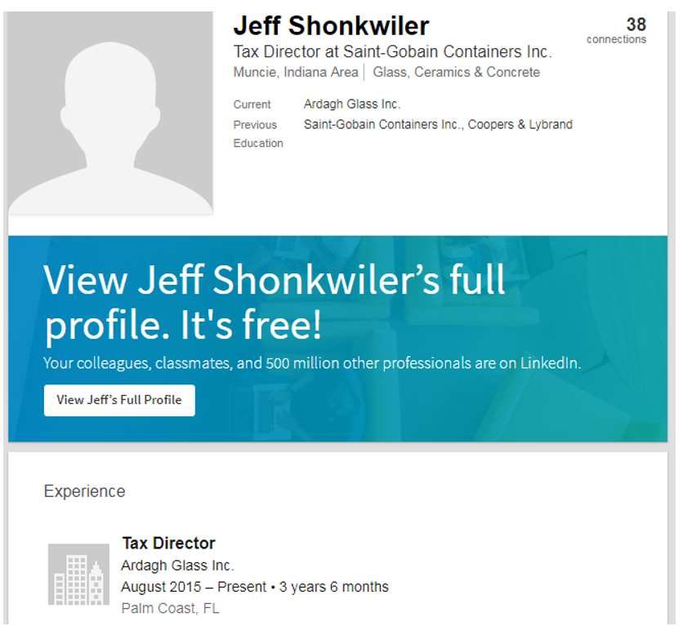

The Tax Meeting Document can be used for Phishing or Social Engineering attack, as we have enough information from the document.

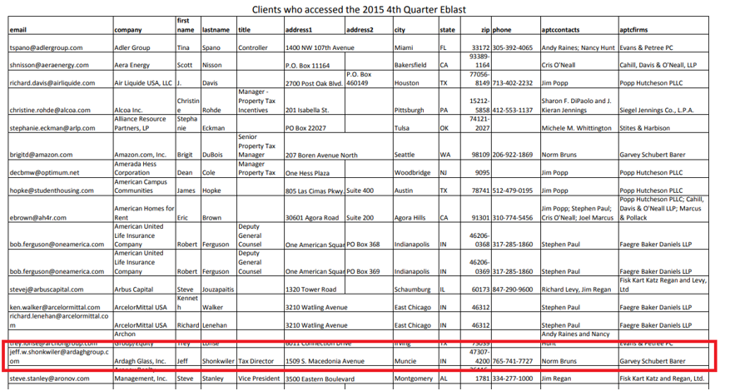

Web Infrastructure Information

We have tried to find out the exact IT Infrastructure information related to Ardagh Group the same manner as we did in Computersuperheroes.com like from published job posts unfortunately it was not successful. We found from one of the posted job for the company that the company are using ASP.NET, C#, AJAX and jQuery for web services.

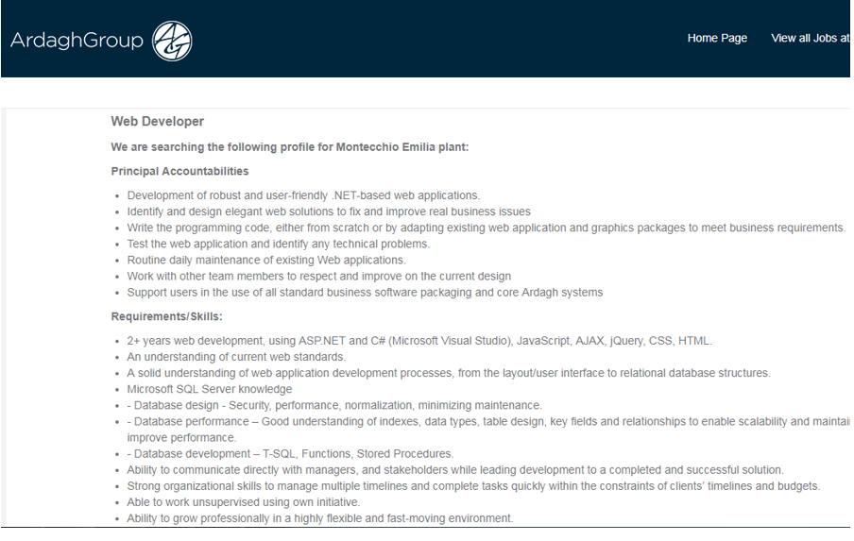

Email Addresses and Employment information

We have also searched for email addresses of the employees of the Company. Several OSINT tools can be used to find out emails of employees. These emails can be used for targeted advertising campaigns and social engineering attacks.

We found out the email structure of the company which is [firstname.lastname@ardaghgroup.com](mailto:firstname.lastname@ardaghgroup.com). With this we can try to find out different emails of employees.

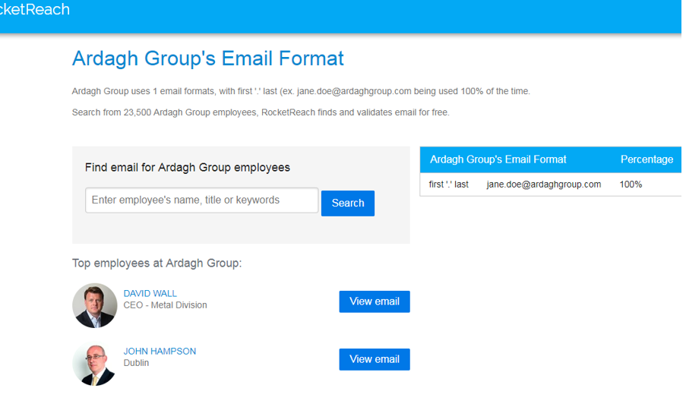

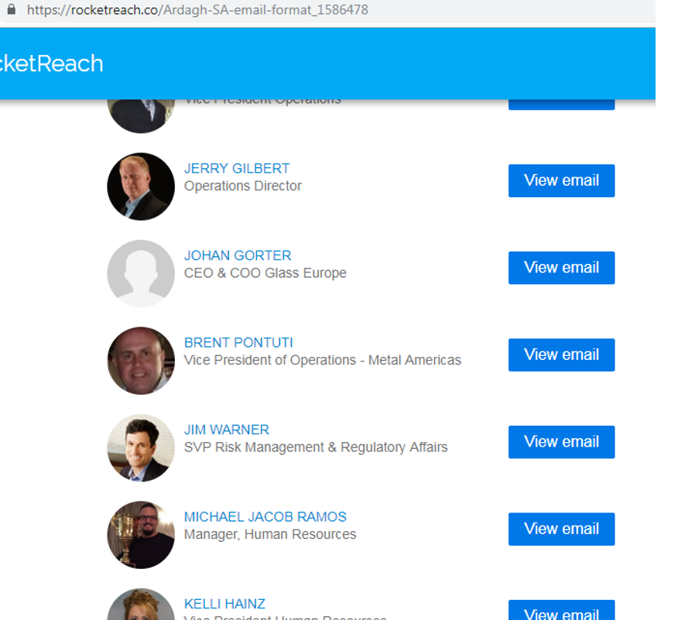

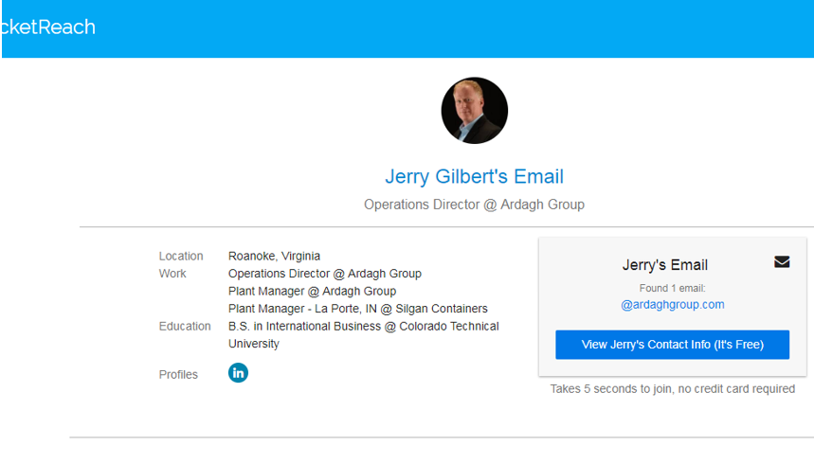

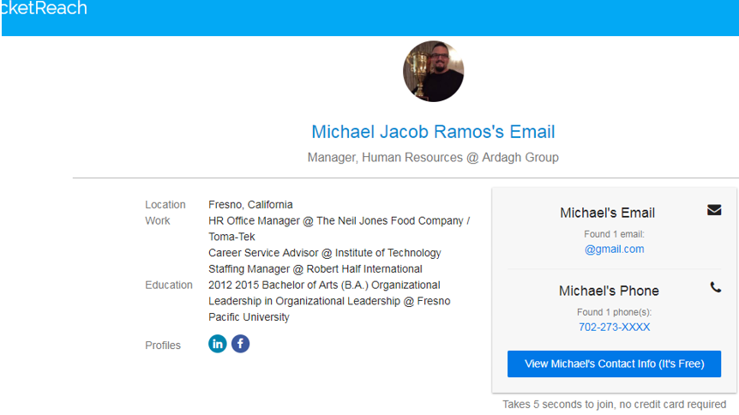

**Question 2**

One of the customers mentioned in question 1, have reported that they have discovered a suspicious activity detected on their firewall. They have asked you to obtain as much information as possible about attack source IP address. You have been asked to use Open Source Intelligence technics only. Any active engagement like scanning, or social engineering is outside of the scope at the moment.

Your target IPs are:

106.75.3.52

46.161.55.108

196.52.43.86

31.184.198.23

94.177.243.42

The above suspected IPs were found in the logs of the organization. They are not Domain servers, but still information cab ne acquired from OSINT tools available on the internet.

The information about an IP that we want include location information, contact if acquired, list on some blacklists and most importantly alerts related this IPs. We can find these information using OSINT tools and without engagement with the target. Given below is the information we found related to the above IPs from internet OSINT tools.

TARGET IP: 106.75.3.52

**Ping command:** The ping command is used to test the ability of the source computer to reach a specified destination computer. Is usually used to verify that a computer can communicate over the network with other computer or network device.

**Number of pings:** By default, the ping sends 4 packets of 32 bytes each

**Size of Packet:** By default, the packets sent are small 32 bytes. A user can set their own size maximum 65500 bytes.

First of all we performed a ping to the IP 106.75.3.52, but the IP was not alive. Traceroute command shows the path, a packet of information takes from your computer to the one you specify. It creates a list of all the routers it passes through until it reaches its destination or fails to and is discarded. In addition, it also shows that how long each hop from router to router takes.

We have performed the traceroute for IP 106.75.3.52 but the trace was not completed. This can be due to several factors, like the target is not active or firewalls are deployed between the source and the target.

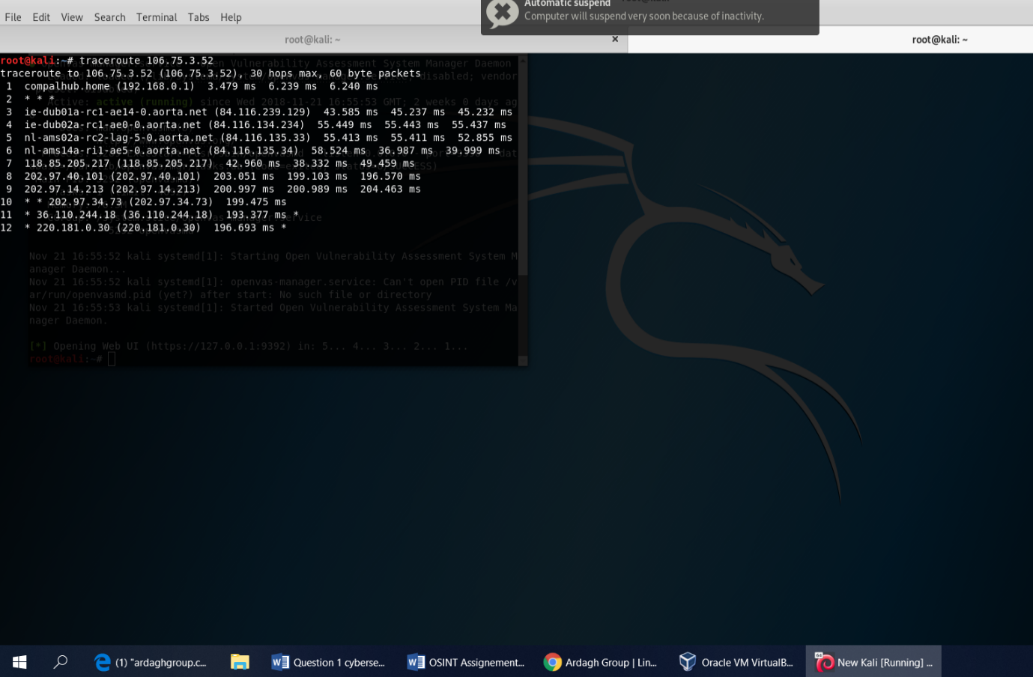

There are some international routes and devices deployed for every device on the internet. Source and target can be reached using these routes and devices. These devices use Border Gateway Protocol to connect with one another. Using OSINT tools like Domain Dossier and Robtex we have found that the IP is located on “AS4808” Router in China.

The IP is registered with Shanghai UCloud Information Technology Company Limited. The contact details for the Internet Service Provider (ISP) is also shown in the below screenshot. These contact details are for the representative of the ISP, which means in case of any suspicious activities the representative of the ISP can be contacted to register a complaint.

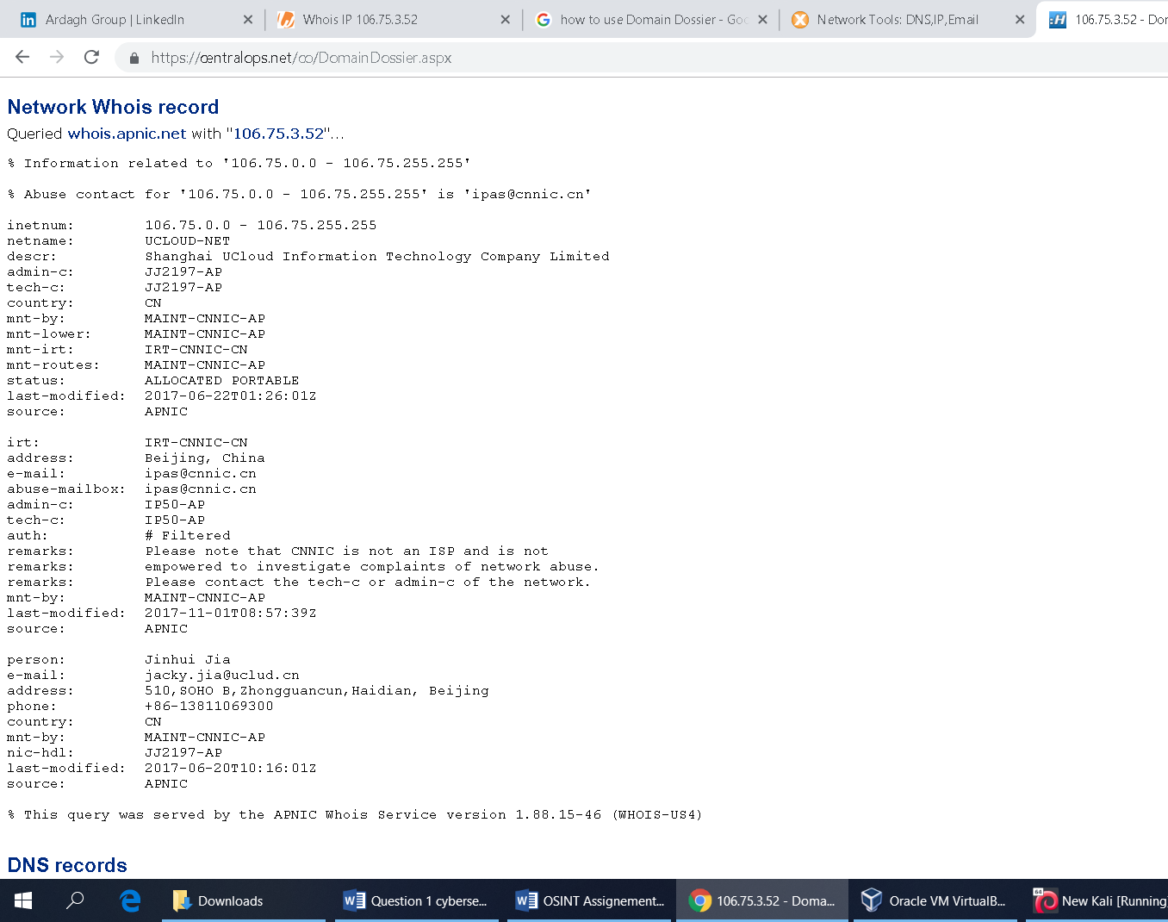

**BLACKLIST CHECK:**

The blacklist check will test an email server or IP address against over 100 DNS based email blacklists. If the IP or email server has been blacklisted, some email sent may not be delivered. These systems are used by email system administrators to try and eliminate spam email messages before they reach their users.

IP address blacklisting is a method of protecting the web and other internet servers from malicious attacks. This is accomplished by setting rules within server software or hardware routers regarding what traffic will be considered an attack, then preventing the computers creating that traffic from connecting again. IP blacklist means, the IP has been reported for malicious activities on the internet therefore it may not be able to communicate with certain destination on the internet.

By using Mx Toolbox, we found out that the IP is listed on various blacklists as shown in the snapshot below.

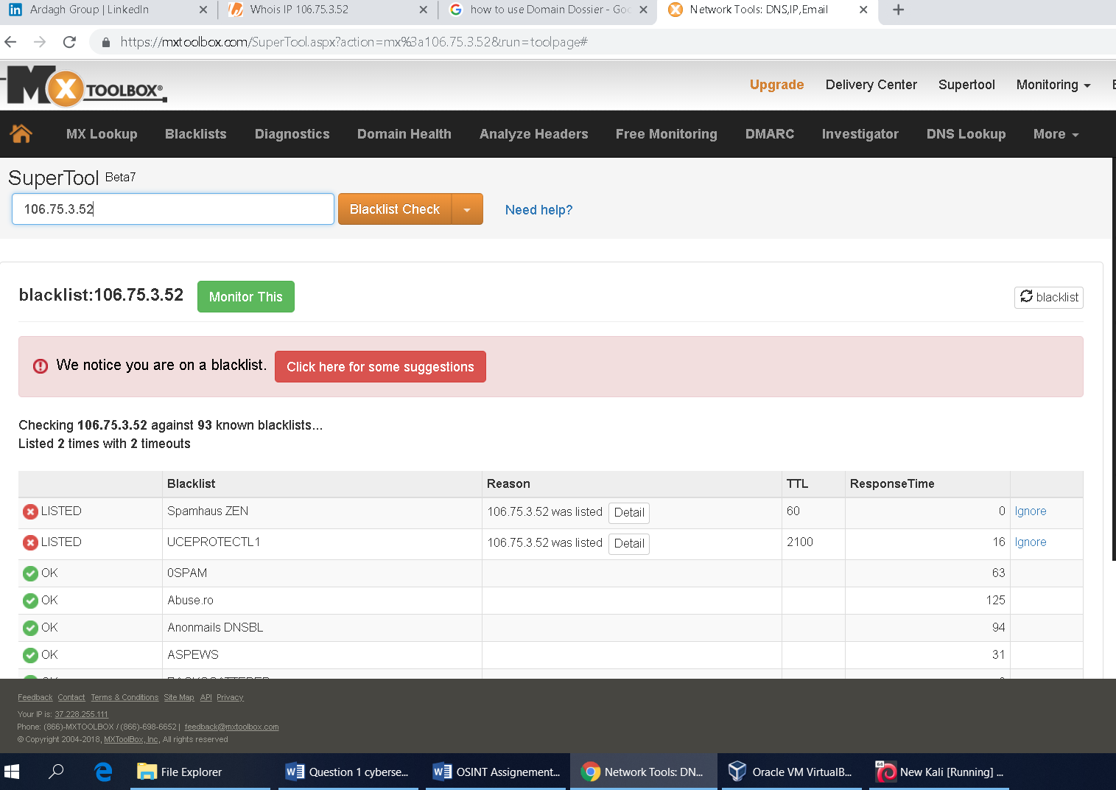

On Spamhause ZEN list if we click in details, we can find that the inclusion of the IP is because “CBL- you have contracted a Virus or Malware that is operating a Botnet, either on your email server on a workstation behind the Network Address Translation(NAT) continual delisting requests without eliminating the virus will result in permanent blacklisting”.

**Finding Abuse or Alert reports of the target IP:**

We can find out the previous record of the target IP from [www.abuseipdb.com](http://www.abuseipdb.com). The IP was reported 311 times from 27 distinct sources. It was first reported in December 2nd 2017, and the most recent was 2 hours ago. The IP is likely to be still actively engaged in abusive activities because a report of abuse activity is received 2 hours ago.

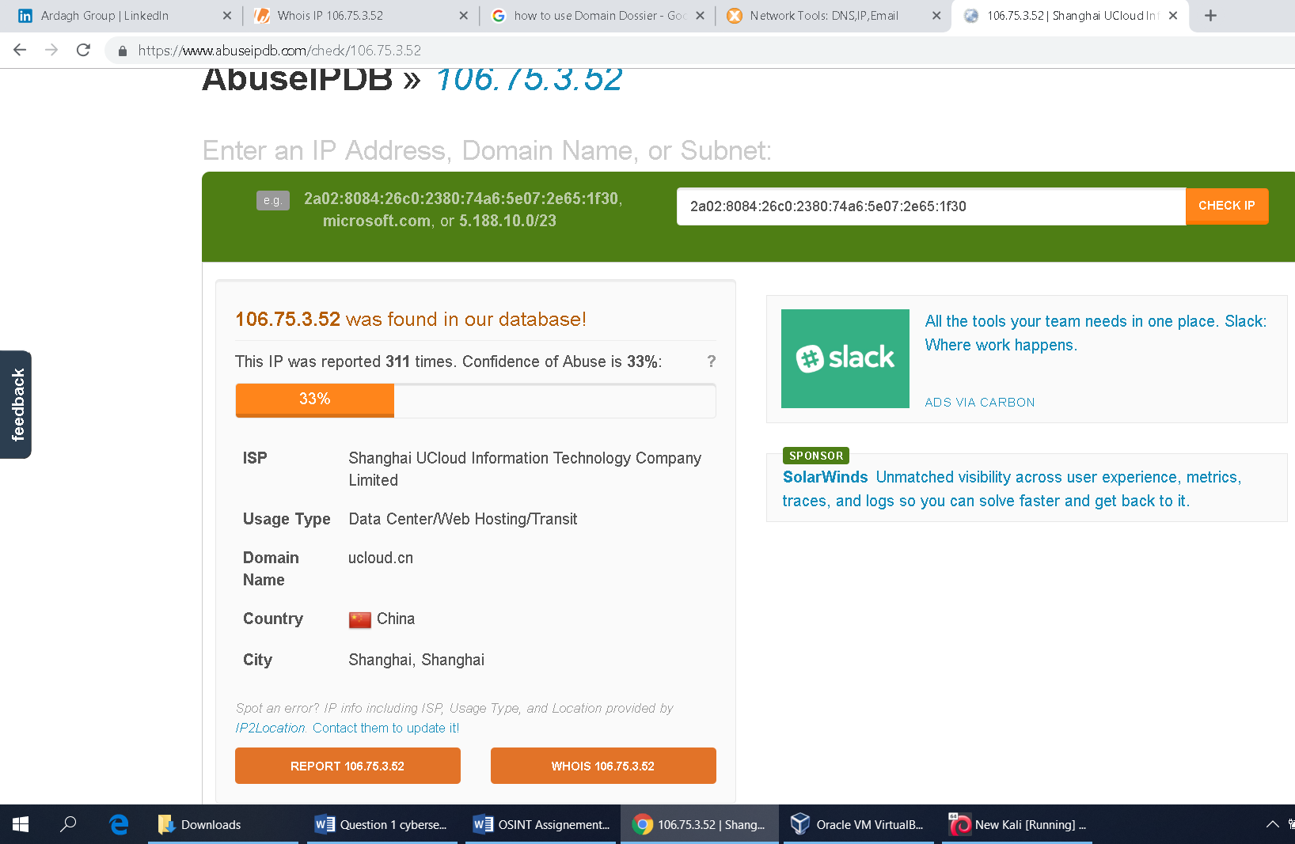

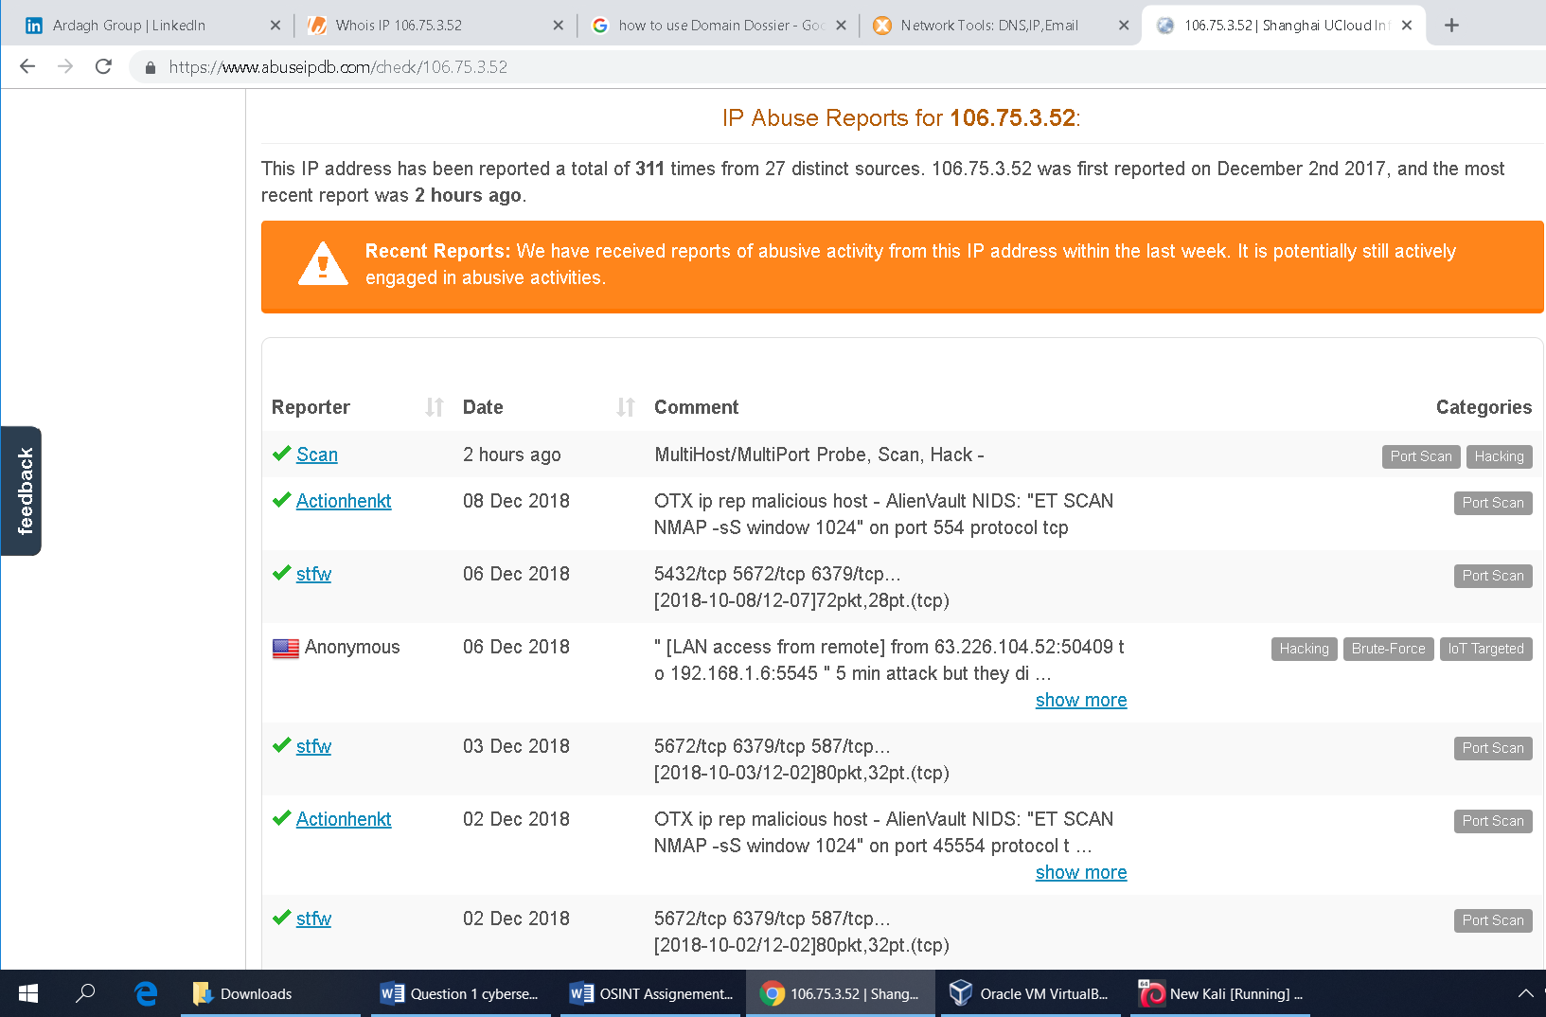

Using awebanalysis.com we can find that the IP may be using proxy for anonymity.

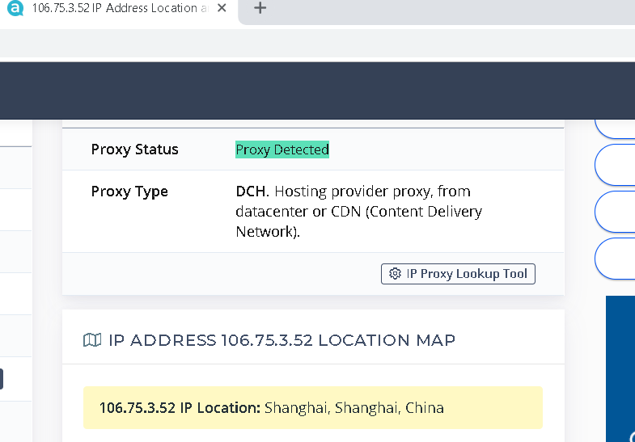

Target IP: 46.161.55.108

First we pinged the target “ 46.161.55.108 “, the target is live. We have traceroute the IP and received a complete router – trace completed.

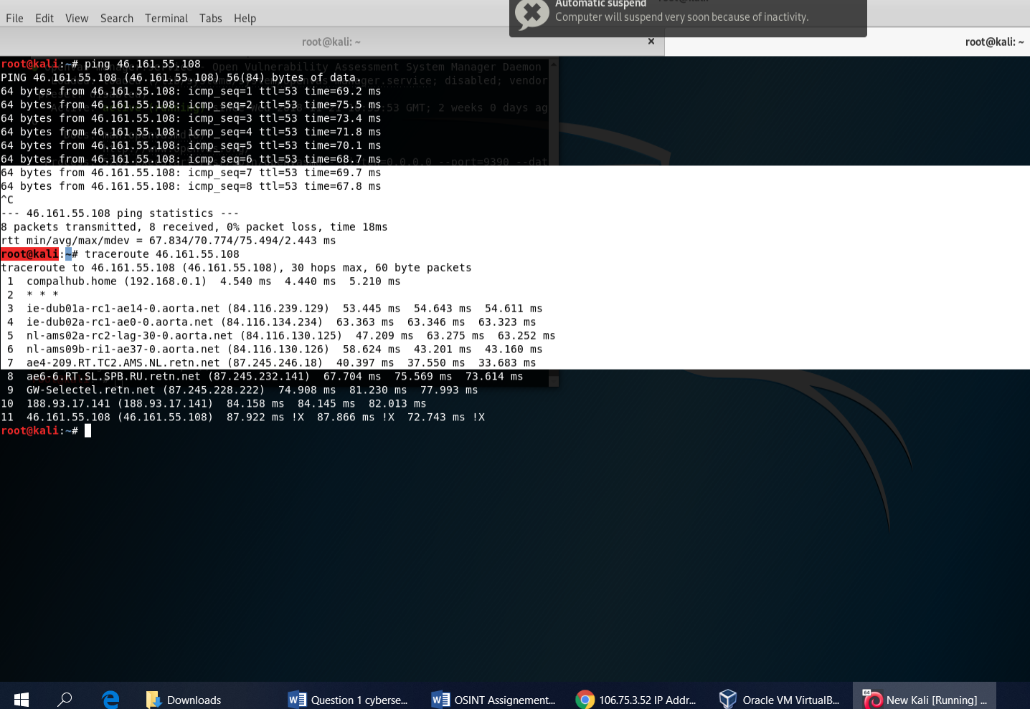

From webanalysis.com we have found that the target IP is located in Moscow -Russian Federation. The ISP is SELECTEL-NET.

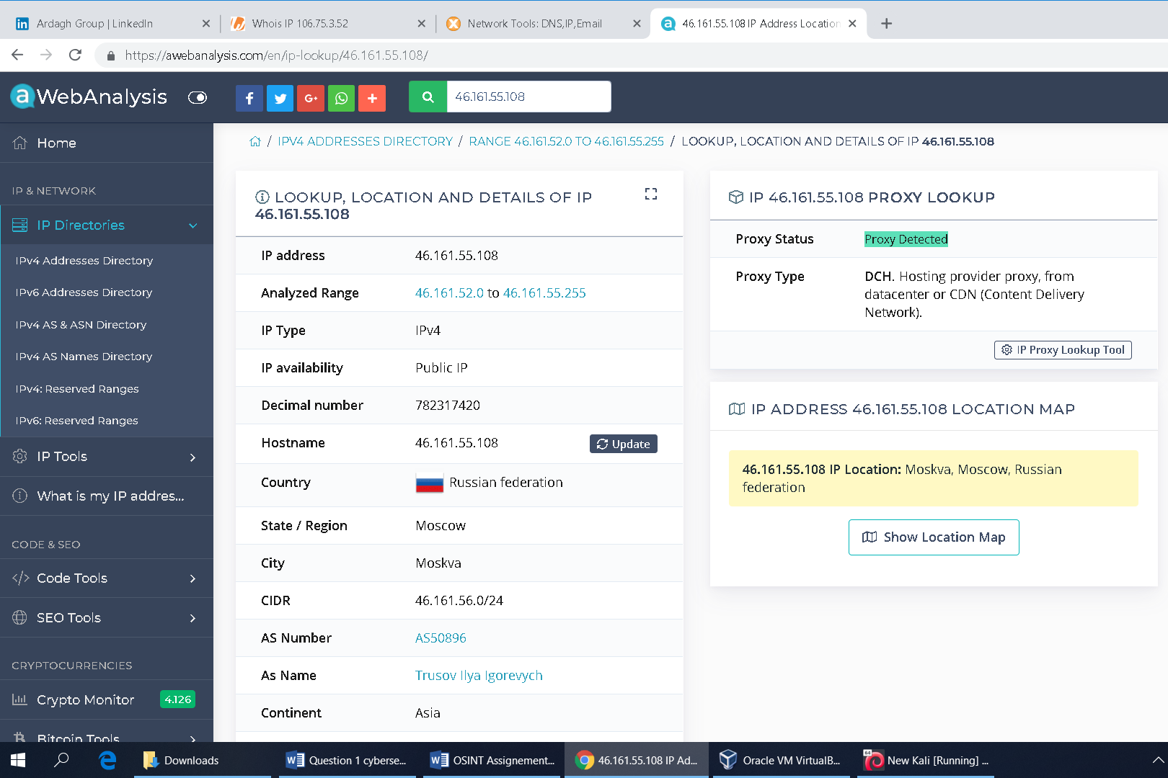

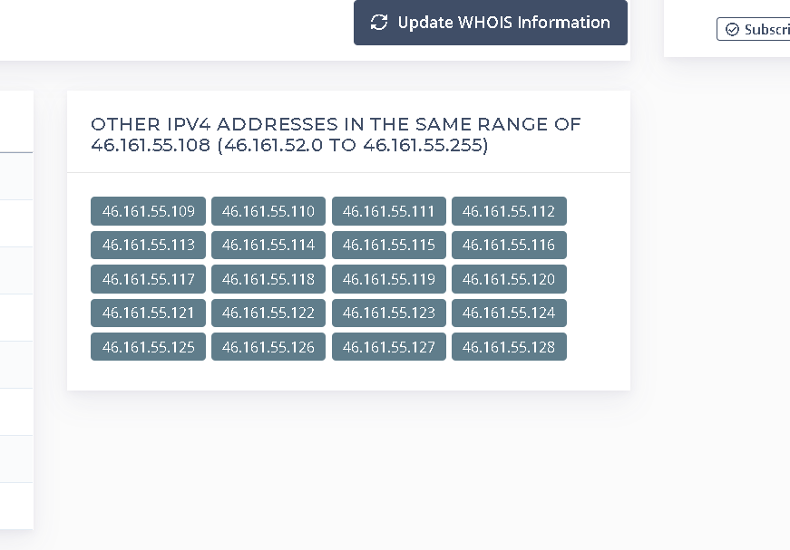

The contact details of the representative of the ISP can also be found from <https://centralops.net/co/DomainDossier.aspx>.

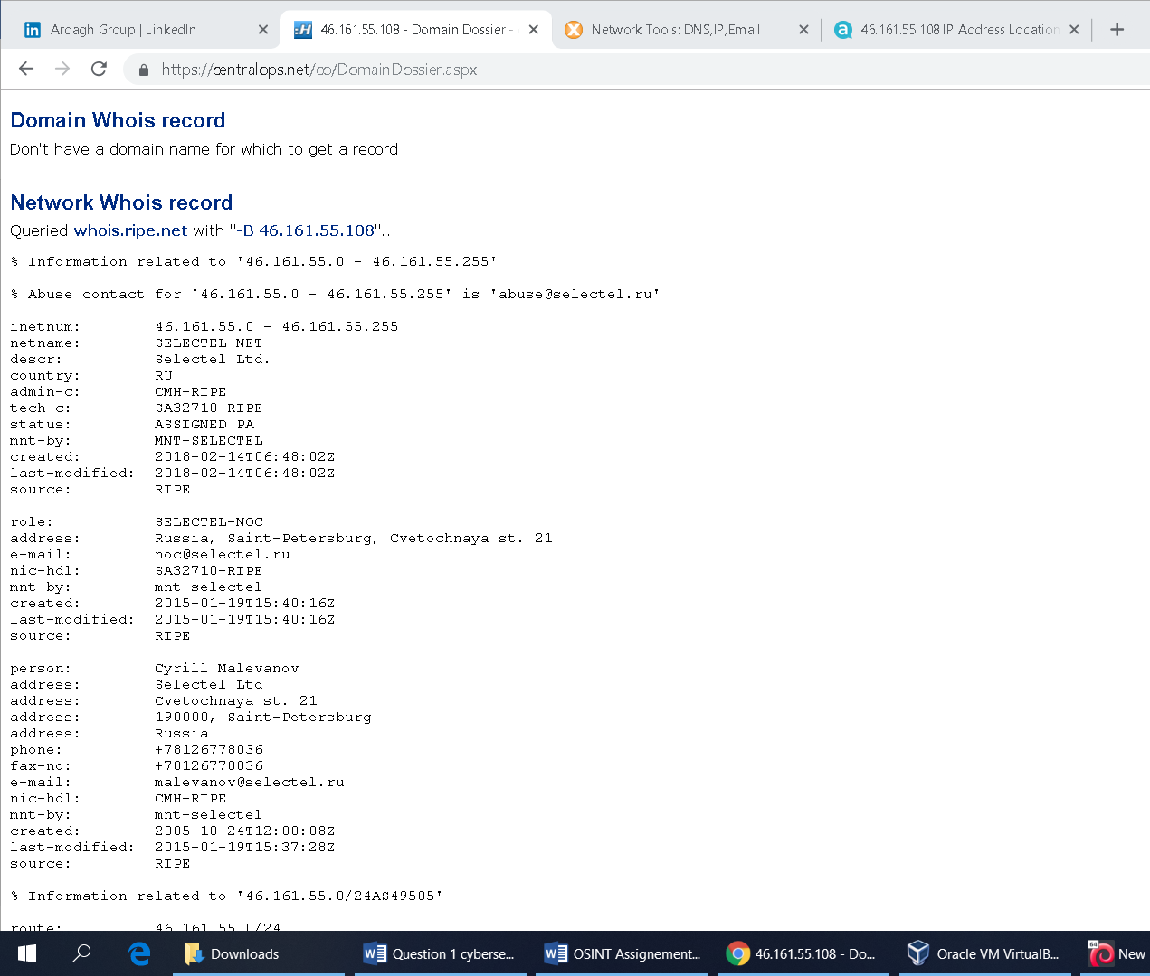

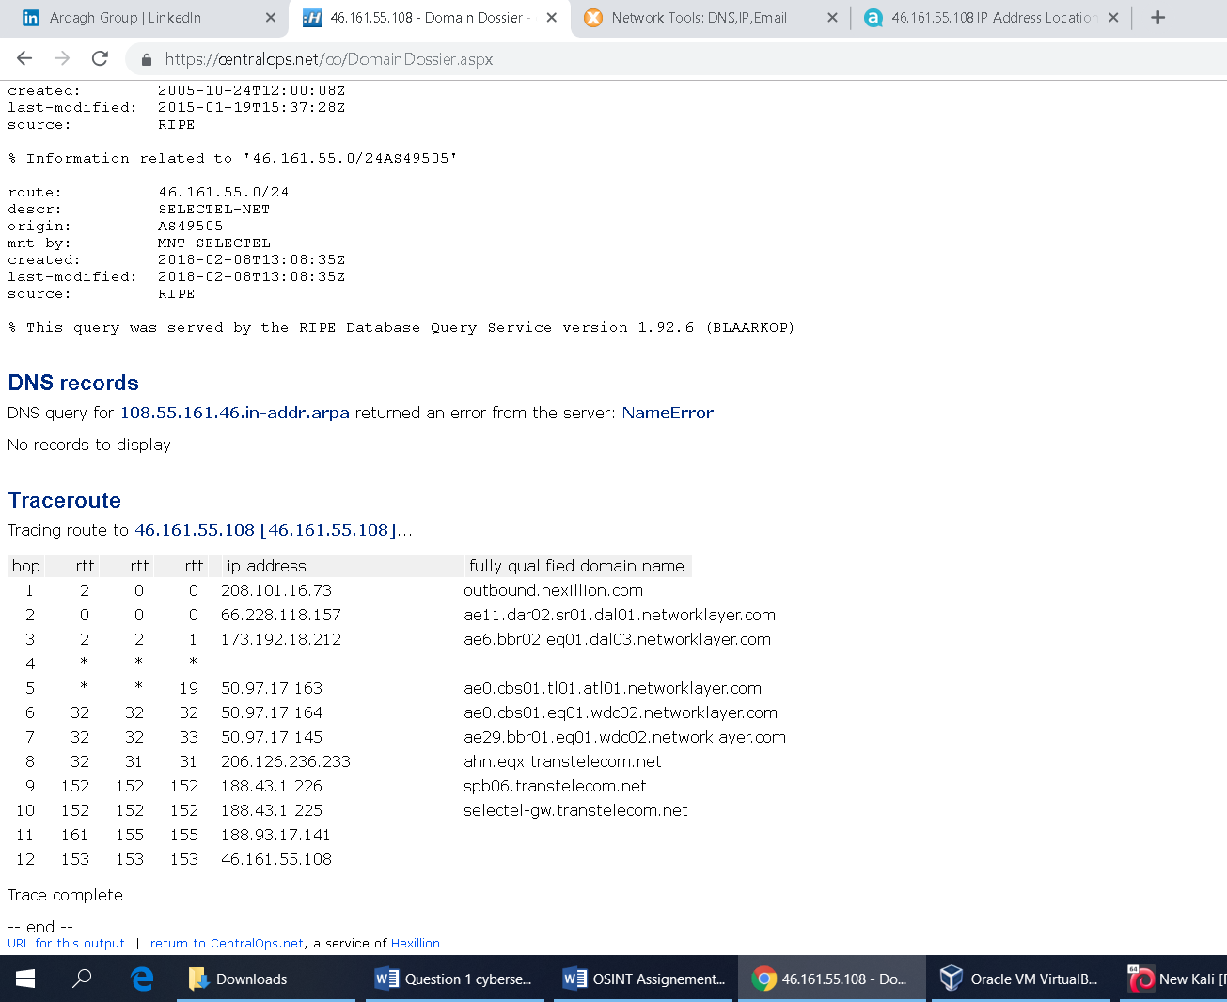

The target IP is also listed in the black lists, which means the IP was involved in some malicious activities.

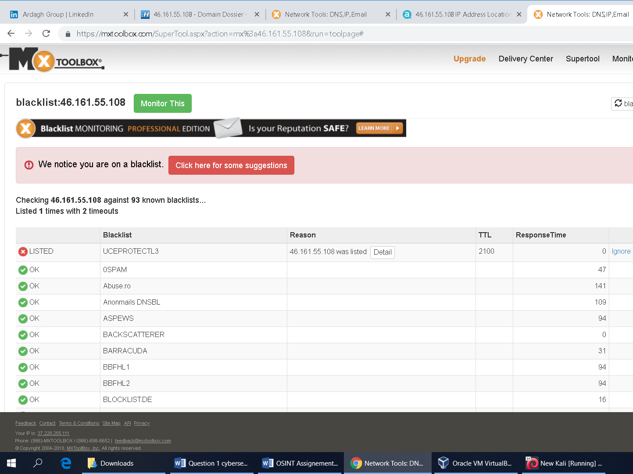

We can find about the previous records of the target IP from [www.abuseipdb.com](http://www.abuseipdb.com). The IP was reported 476 times and the most recent reports was 7 months ago. It is possible that this IP is no longer involved in abusive activities.

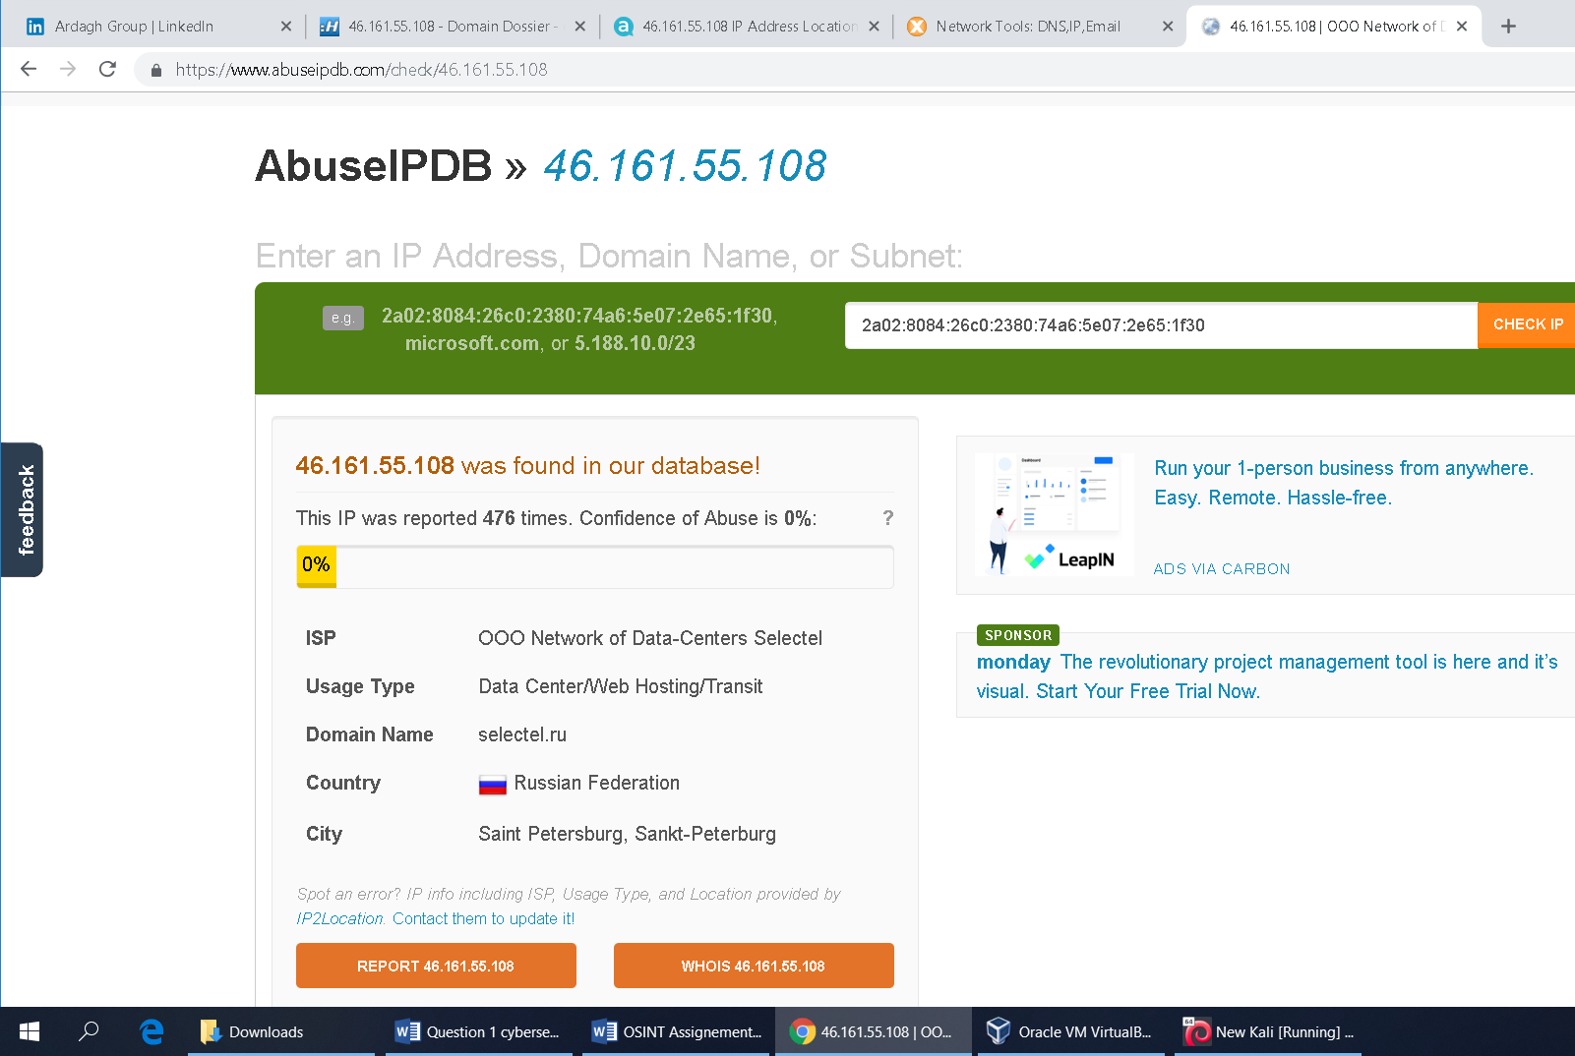

The below snapshot is of the internet users who reported the malicious activities of this IP. Some of which are target of “port scan”, “brutforce password attack” and “web Bot exploit”. The IP is certainly involved in malicious activities.

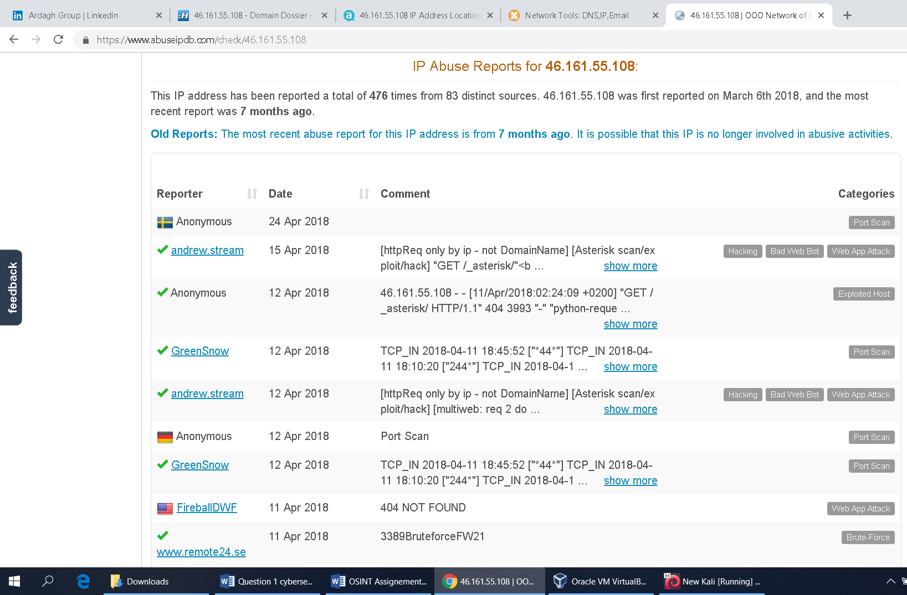

**Target 3: 196.52.43.86**

First we pinged the target “ 196.52.43.86 “, the target is live. Then traceroute the IP and got a complete router – trace completed.

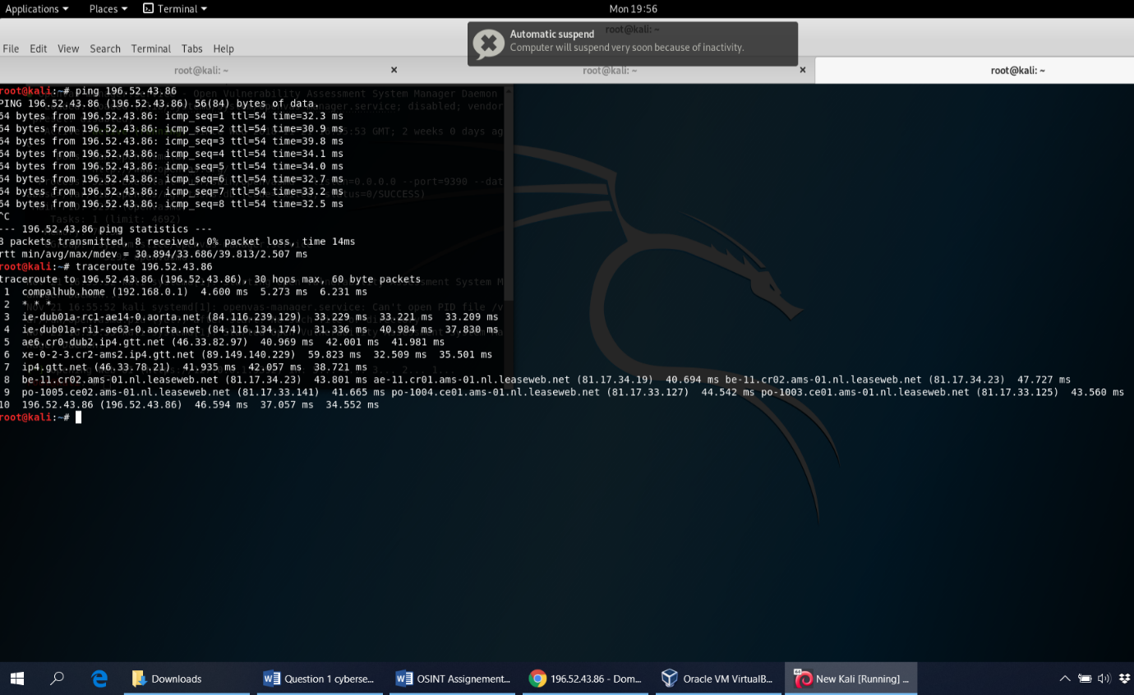

Using awebanalysis.com we have found that the target IP is located in Edison, New Jersey, United States. The IPS is Net Systems Research, LLC.

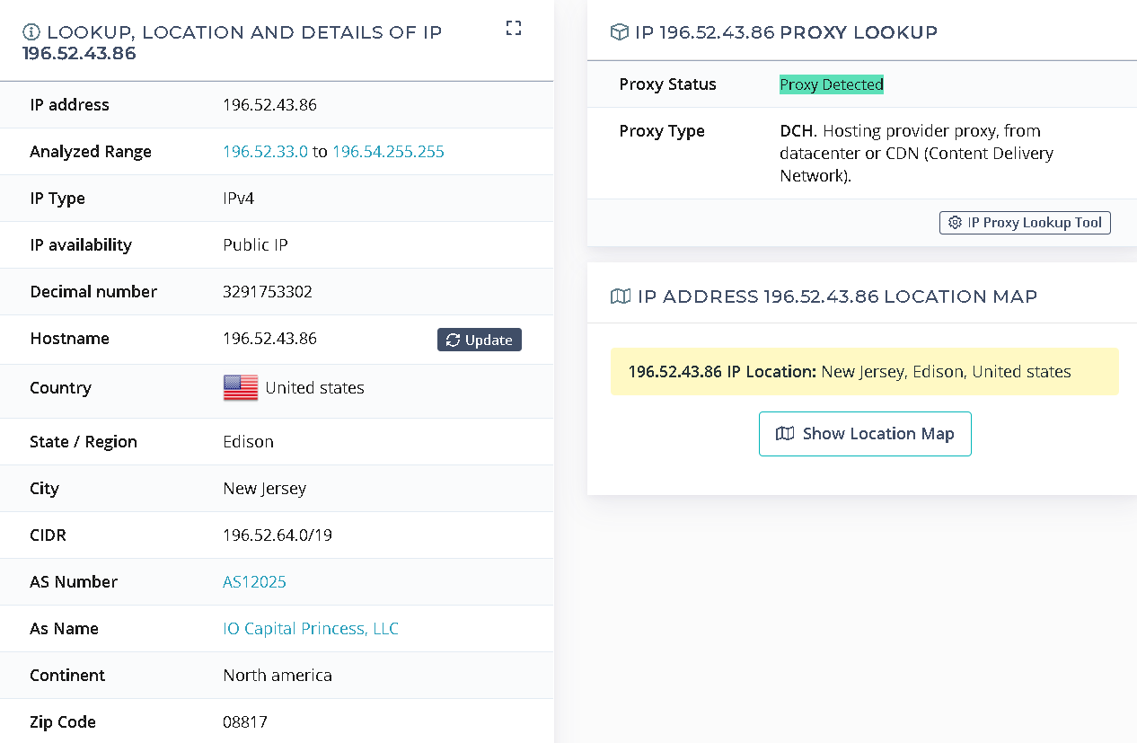

The contact details of the representative of the ISP can be also be found in the snapshot below.

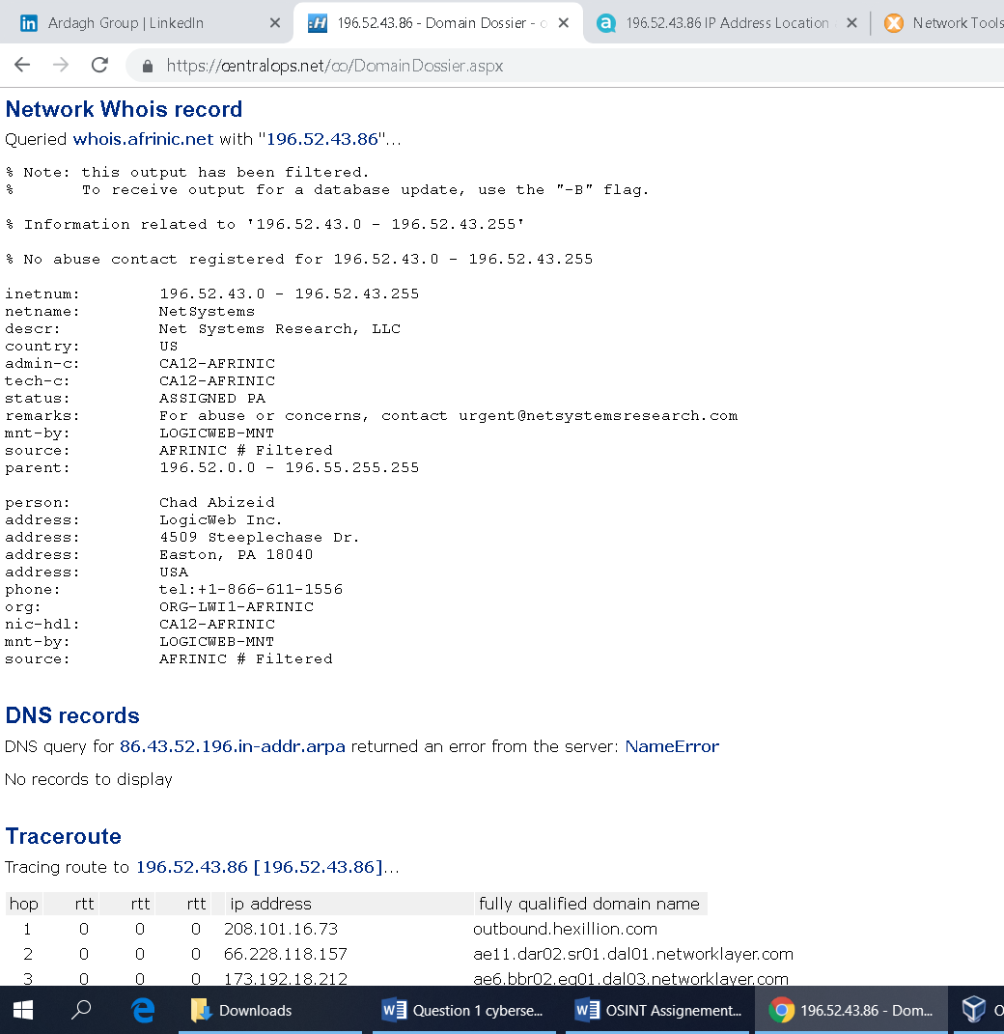

The target IP is also listed in a couple of black lists. It is involved in malicious activities like spamming, scanning etc.

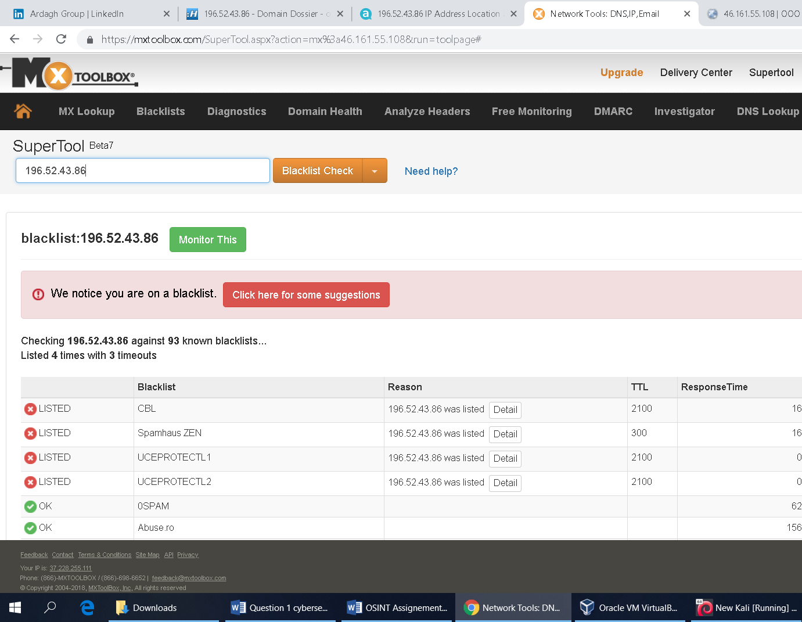

We can find out the previous record of the target IP from [www.abuseipdb.com](http://www.abuseipdb.com) . The IP has been reported 1105 times from 73 distinct sources. The IP was first reported in January 12th 2018 and the most recent report was 3 hours ago as shown below. It is likely still actively engaged in abusive activities.

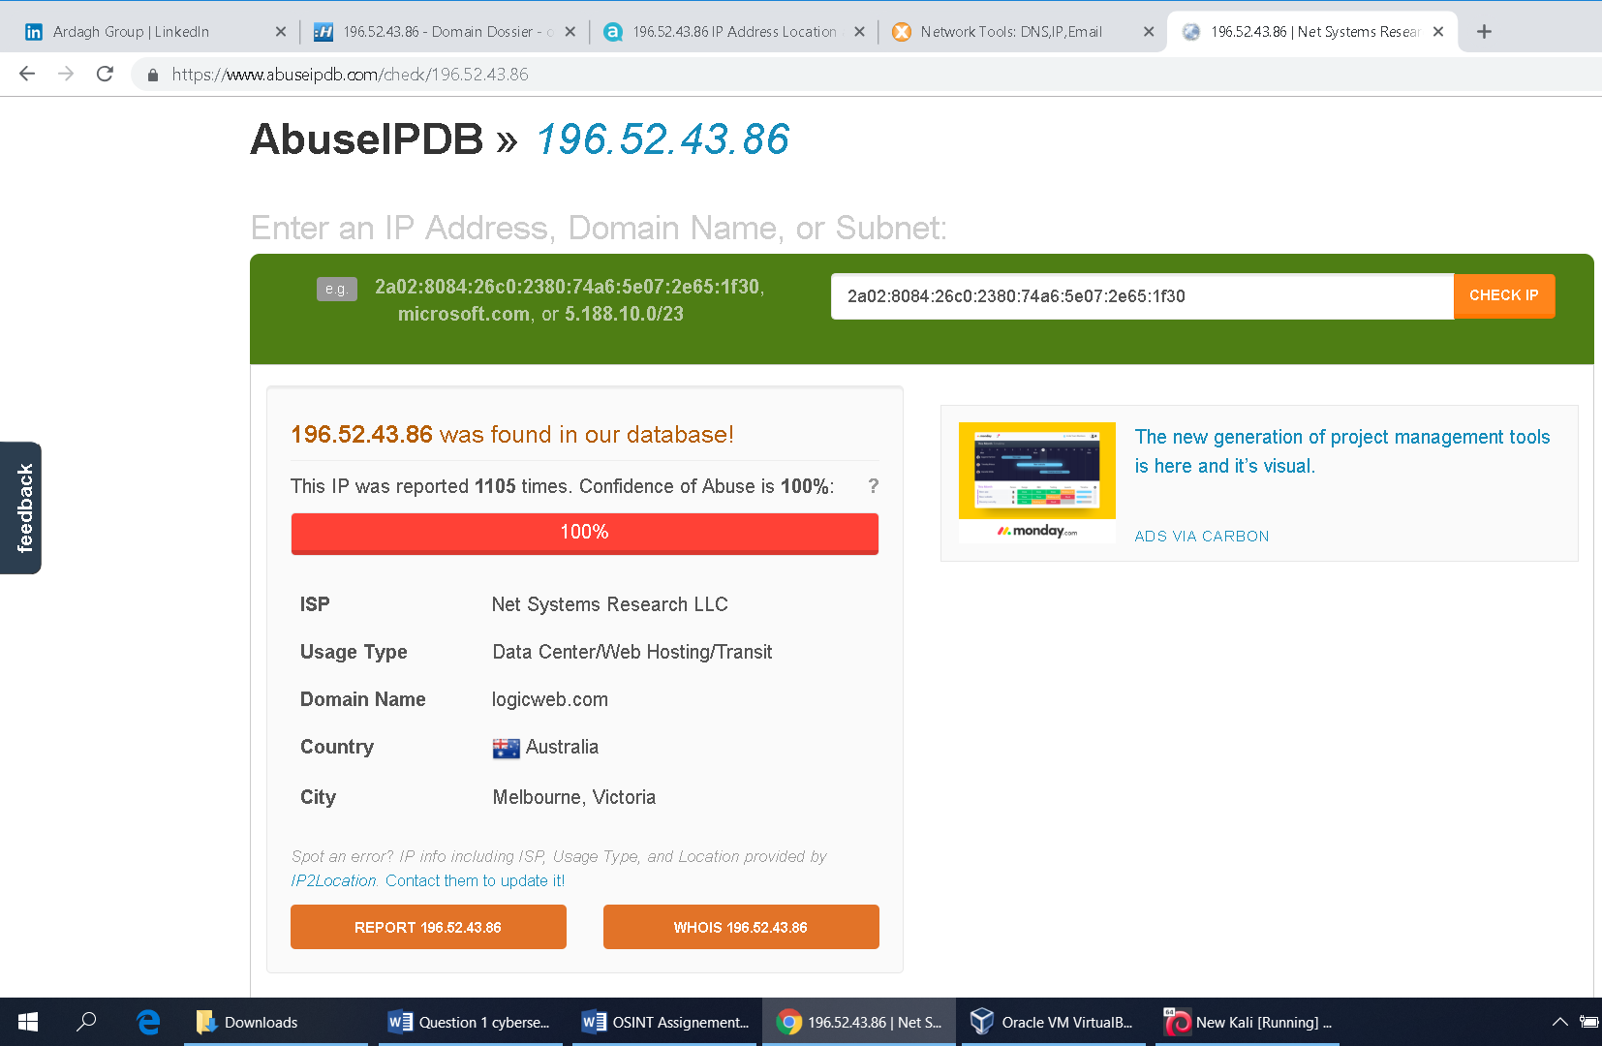

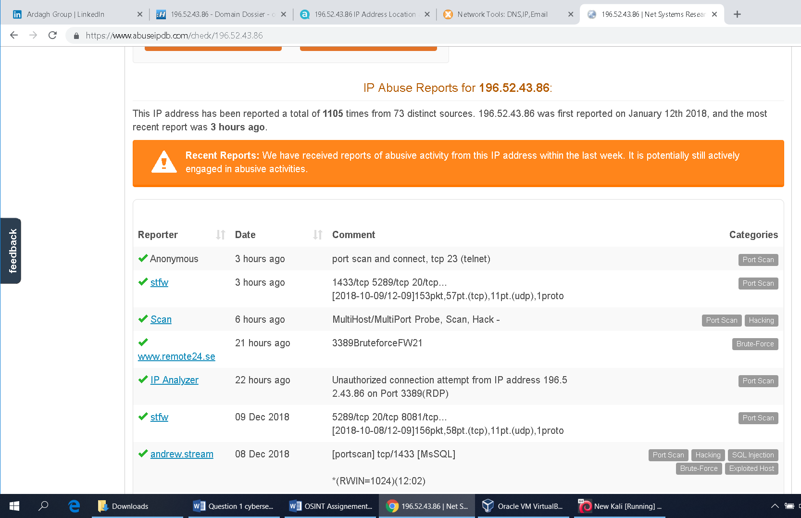

“The Shodan also marked it as an internet scanner”

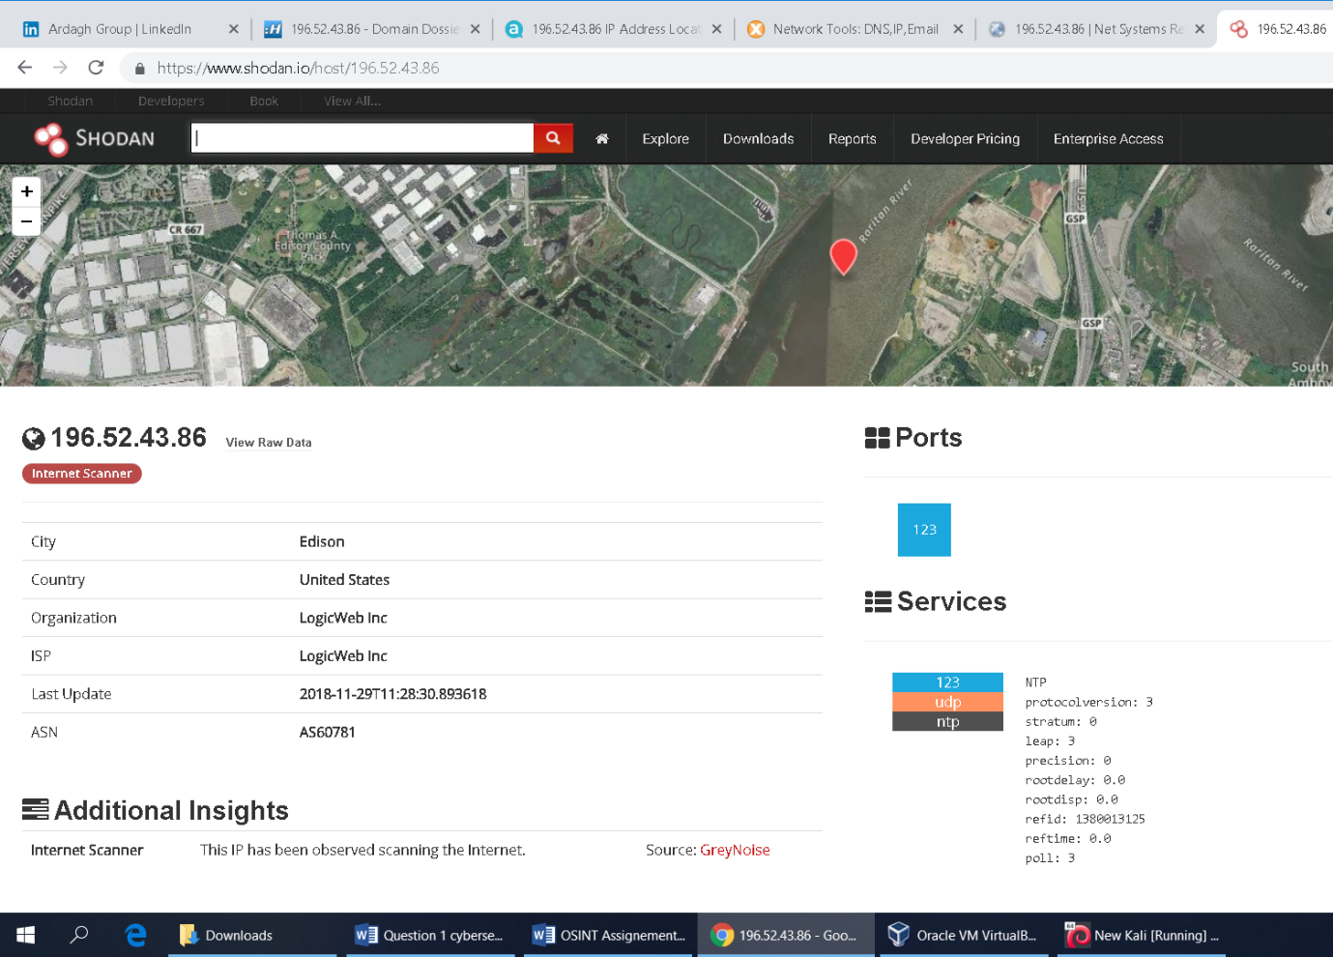

Target 4: 31.184.198.23

First we have pinged the target “31.184.198.23”. The target was live. Then we traceroute it, and got a complete router – Trace Completed.

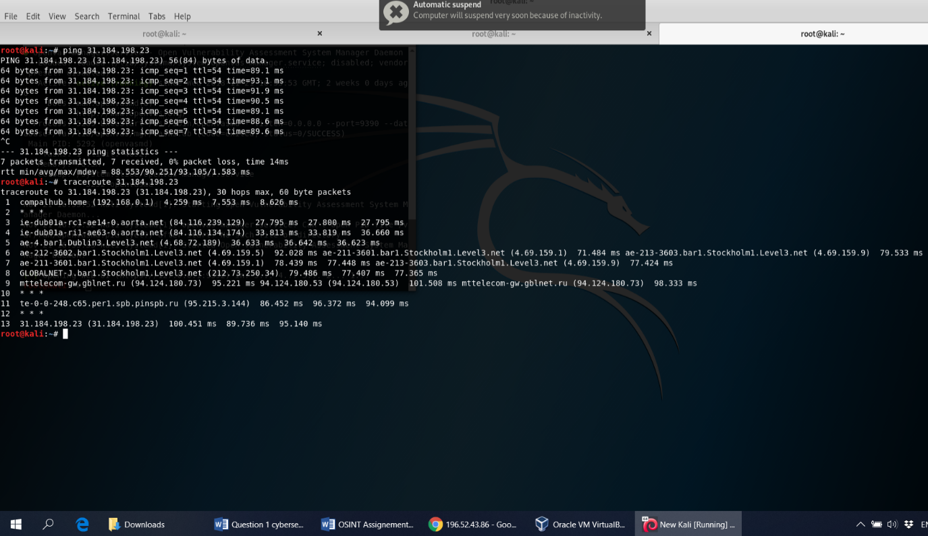

Using OSINT tools like Domain Dossier and Robtex we have found that the Ip is located on BGP “AS44050” router at Saint Petersburg, Russia. The IPS is Petersburg Internet Network ltd.

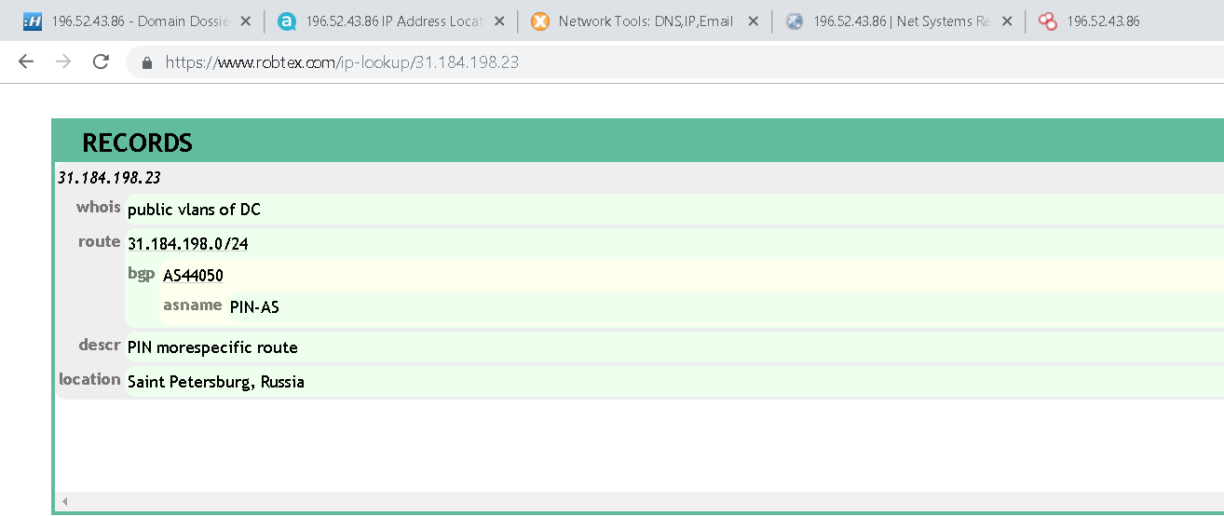

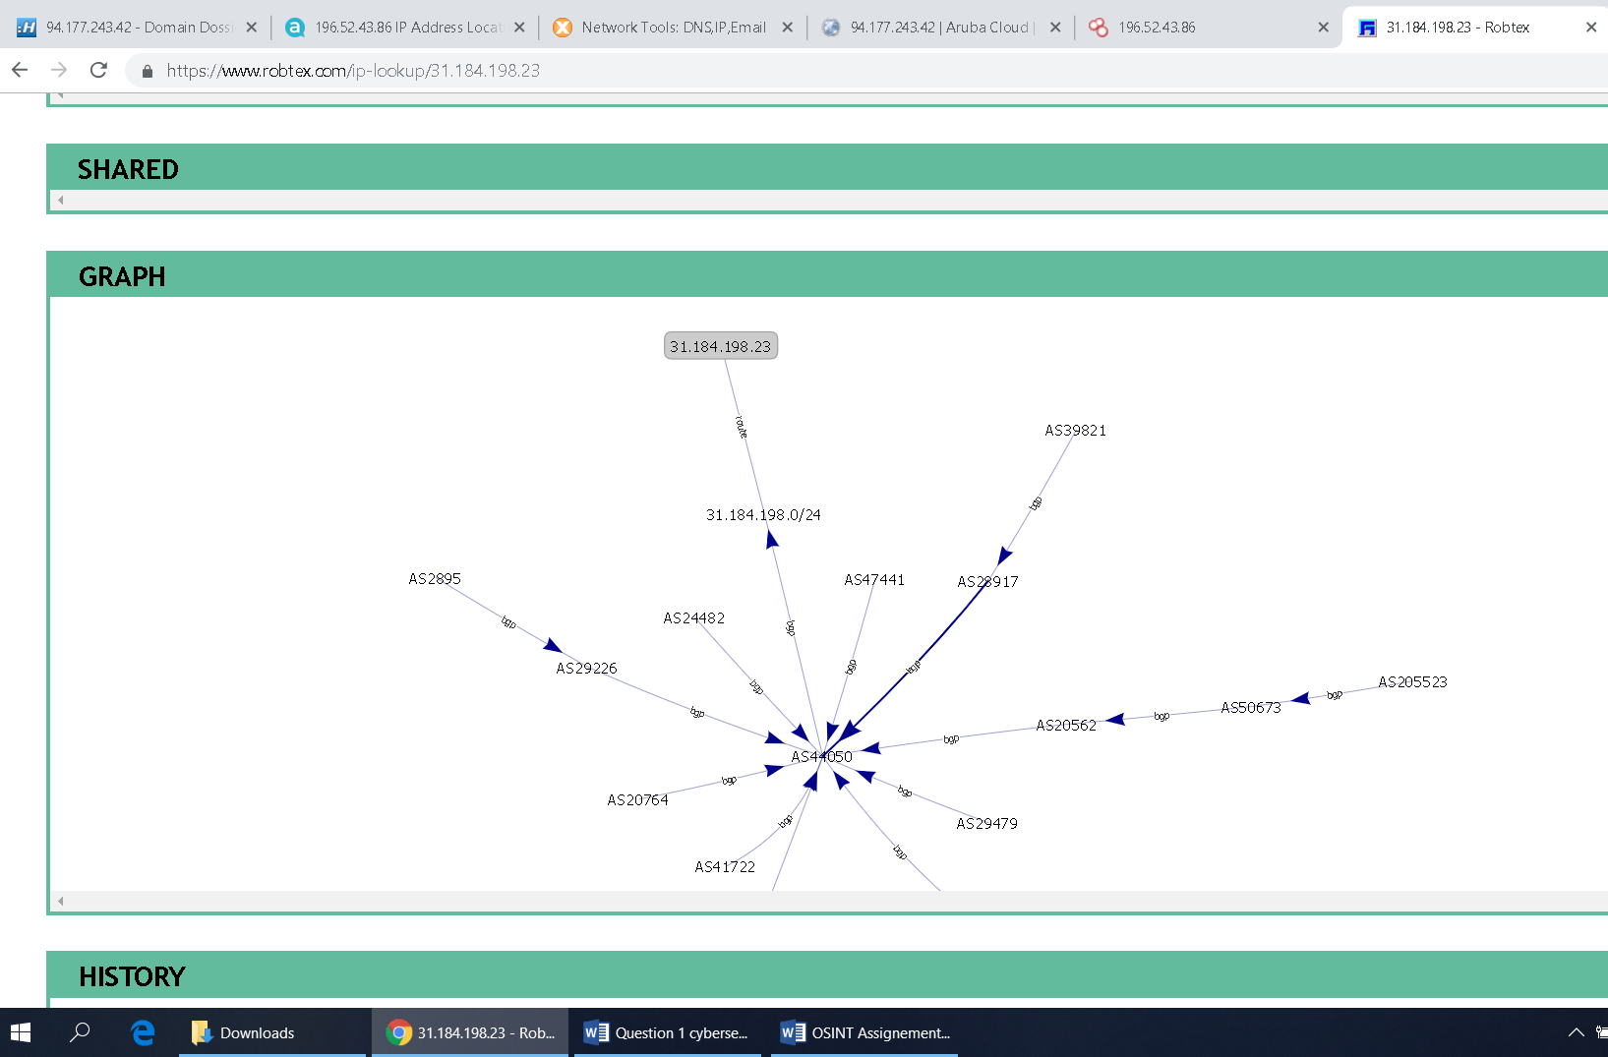

Geolocation of IP

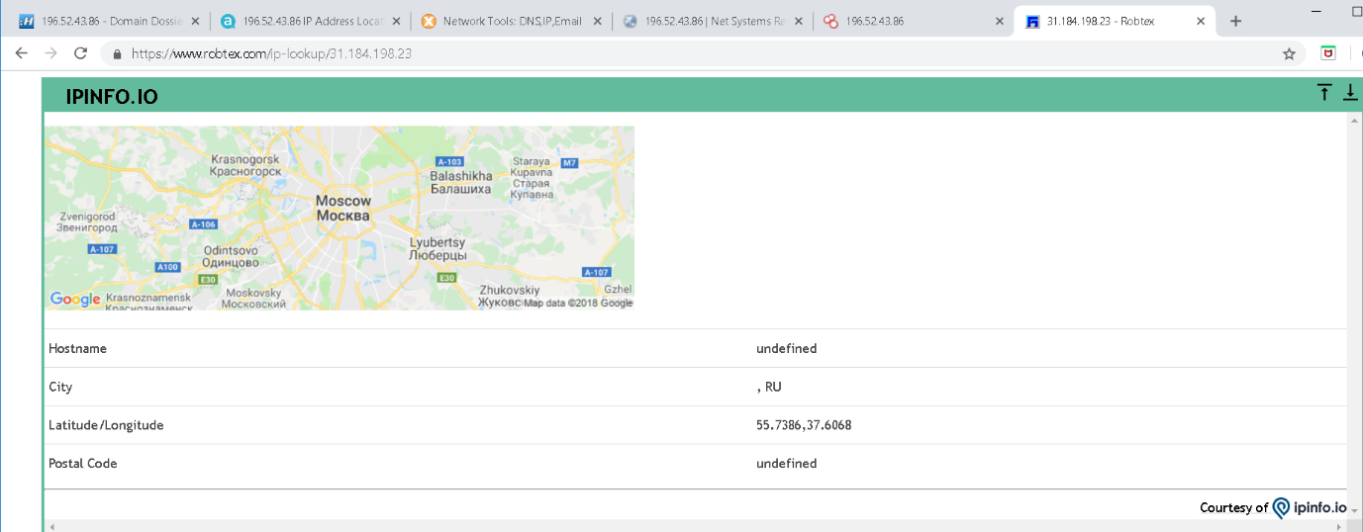

Contact details of the representative of the IPS can also be found at the URL in the snapshot below.

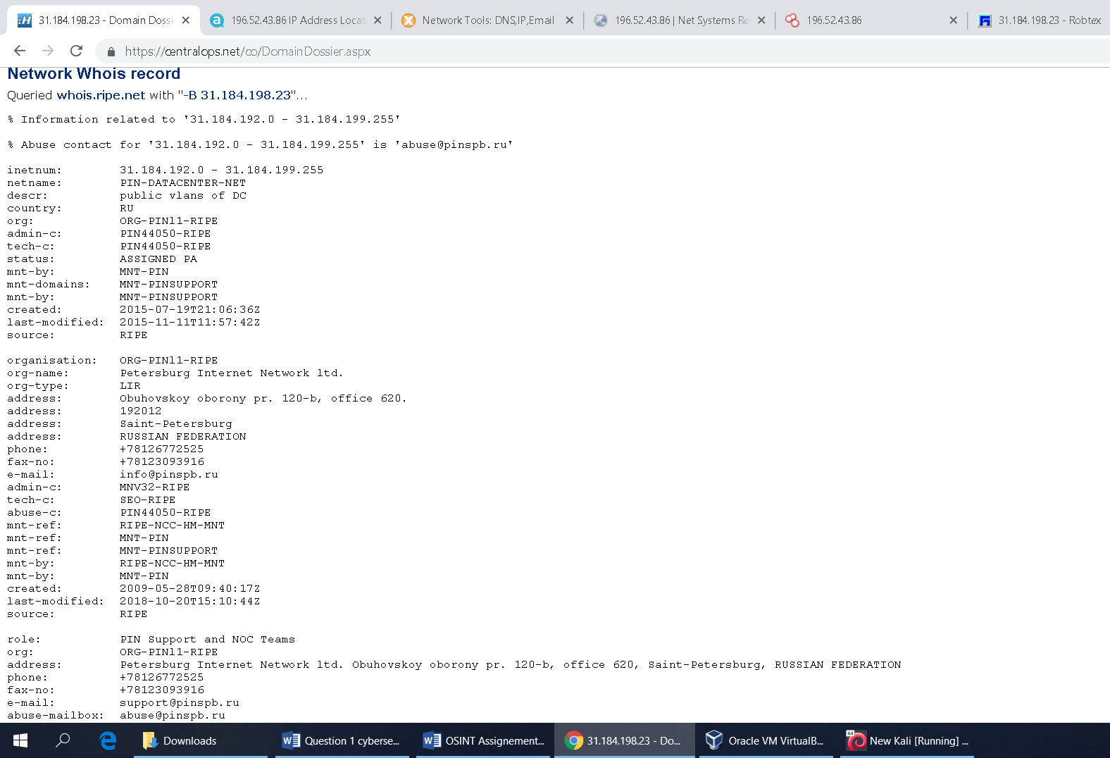

According to Mx Toolbox Black list testing, the target IP is not listed in any black lists. We can confirm this using mx toolbox as shown below.

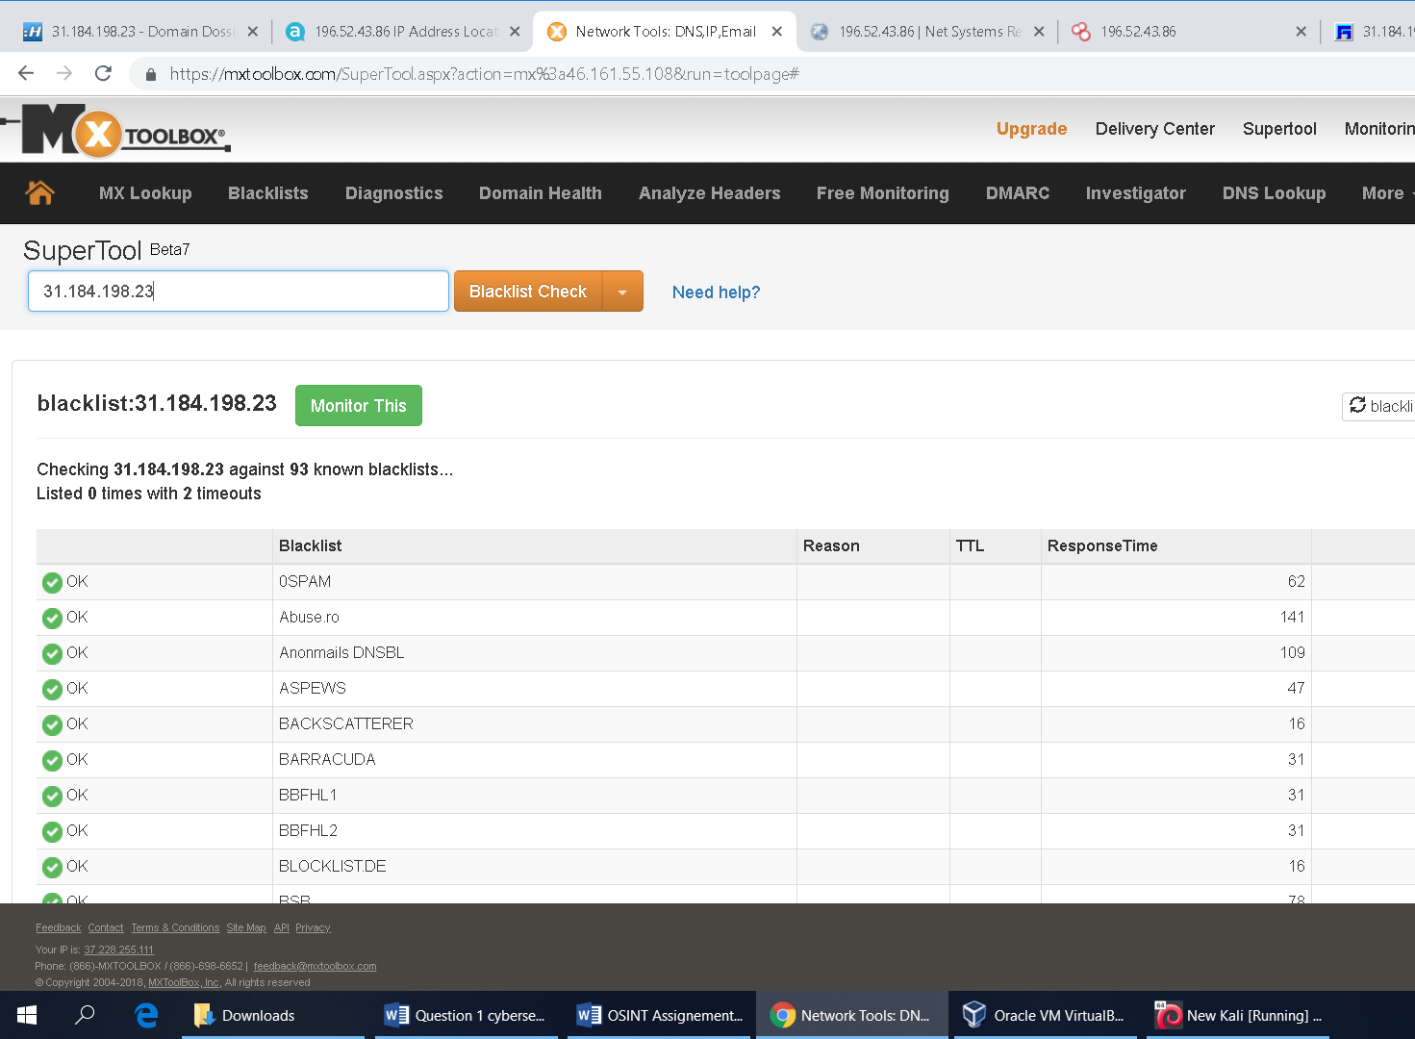

We can find out the previous record of the target IP from [www.abuseipdb.com](http://www.abuseipdb.com) . This IP address has never been reported of any abuse, see snapshot below.

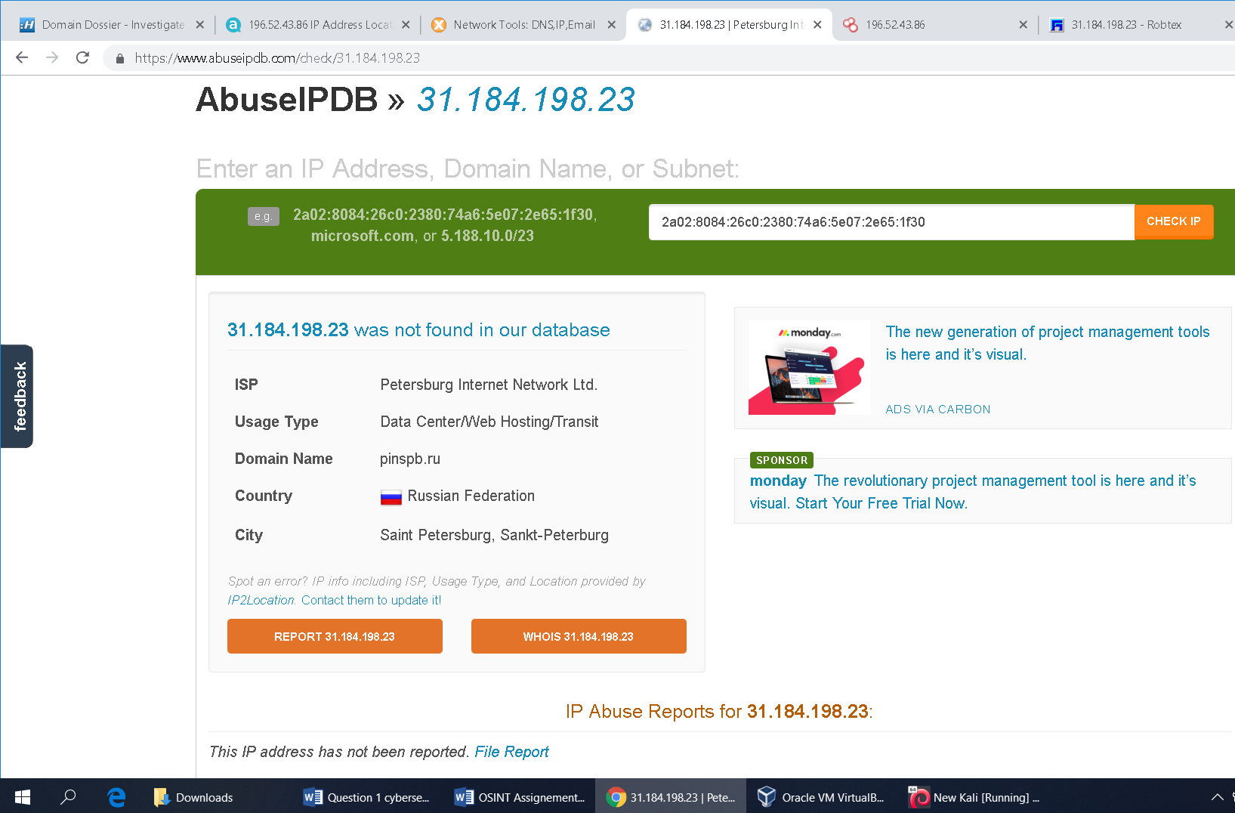

Target 5: 94.177.243.42

First we have pinged the target “94.177.243.42”. The target was not live. Then we traceroute it, and got request time out.

Using Robtex and Domain Dossier we have found that the IP is located on BGP “AS199653” Router in Paris, France. It is hosted by Aruba.FR Network.

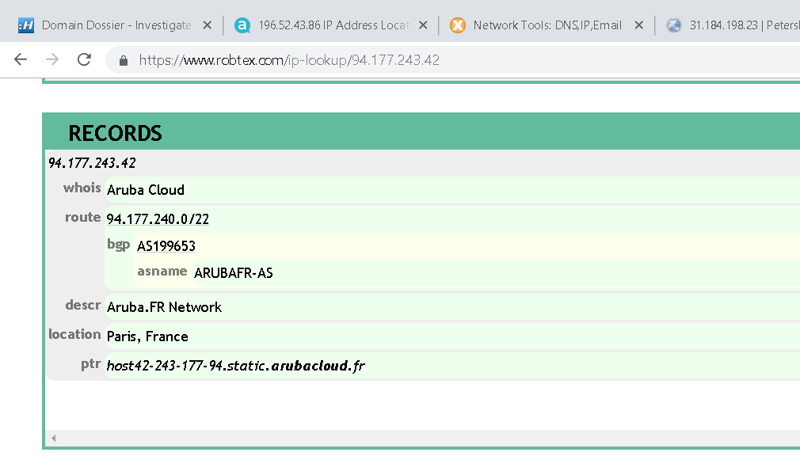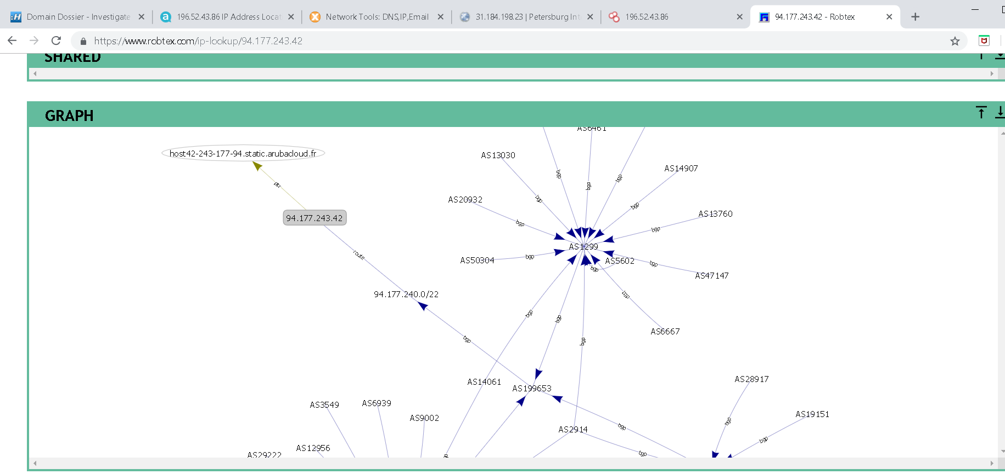

The contact details of the representative of the ISP can also be found at Domain Dossier as shown in the snapshot below.

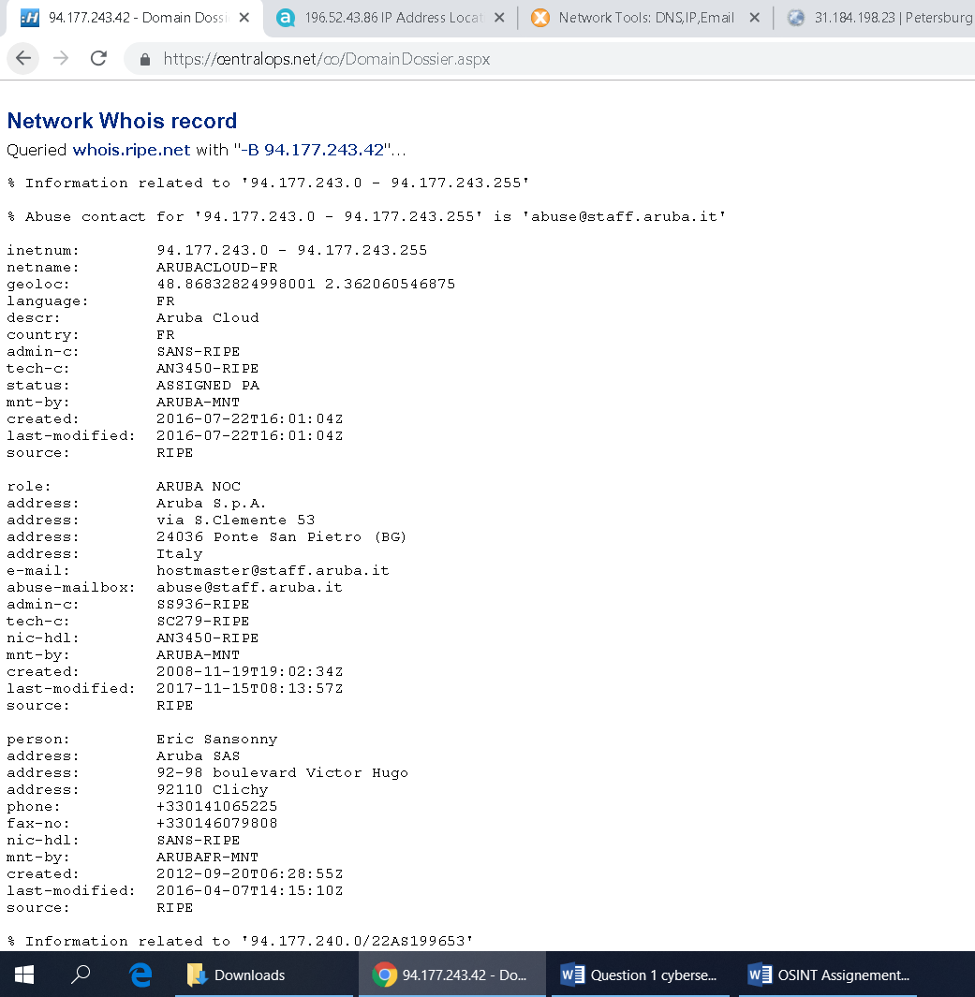

Similarly, according to Mx Toolbox black list testing, the IP is not listed in any black list. We can see using mx toolbox.

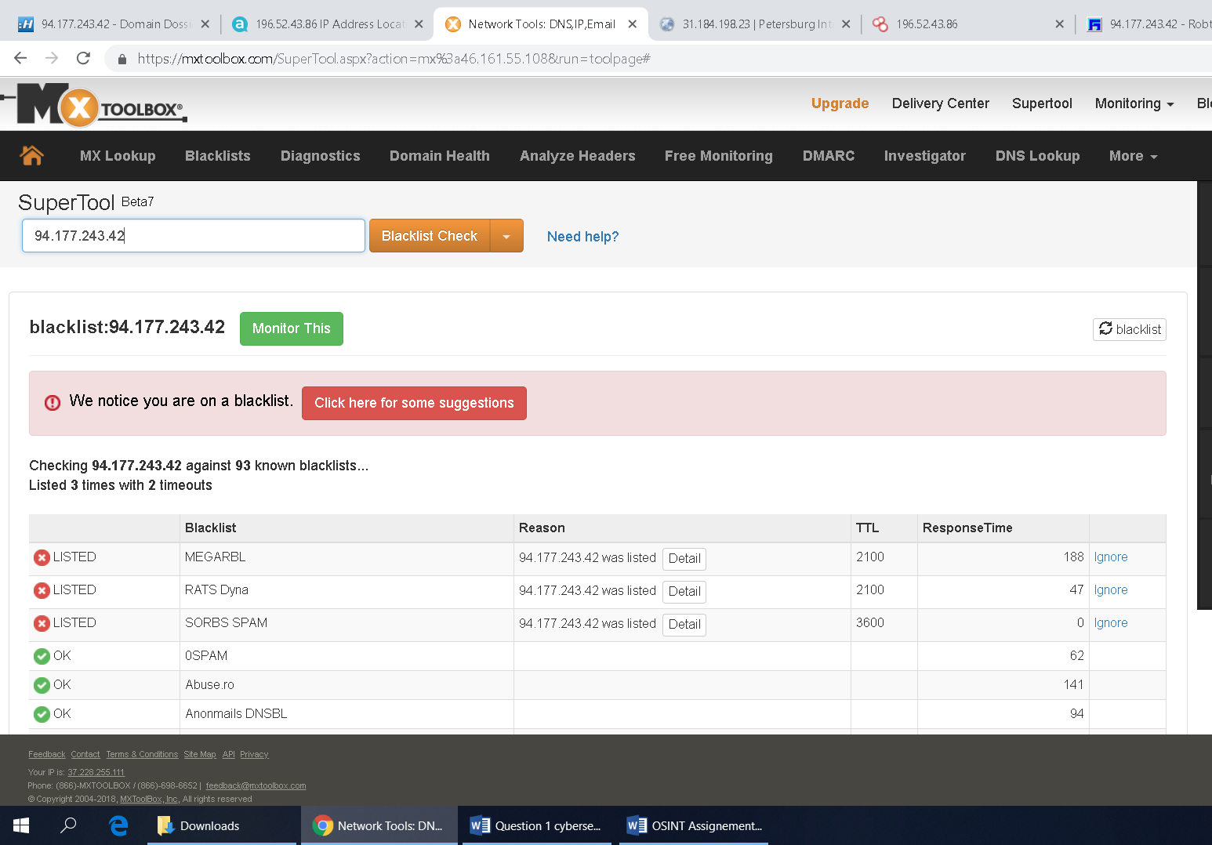

We can find out previous record of the target IP from [www.abuseipdb.com](http://www.abuseipdb.com). The IP address is reported only 2 times from 1 distinct source. The IP was first reported in March 21st 2018, and the most recent report was 8 months.

Old reports: The most recent abuse report for this IP address is from 8 months ago. It is possible the that the IP is no longer involved in abusive activities. Confidence of abuse is 0%.

Full details of the IP and its engaged activities can be found below.

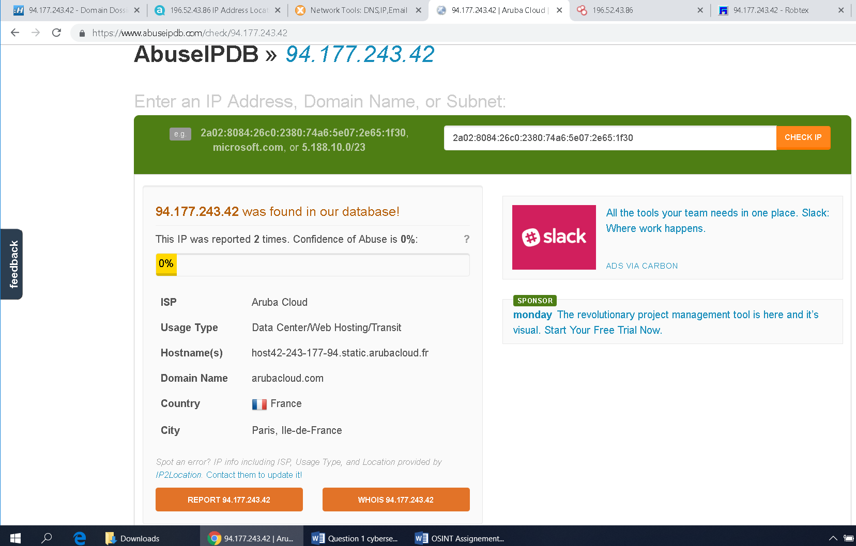

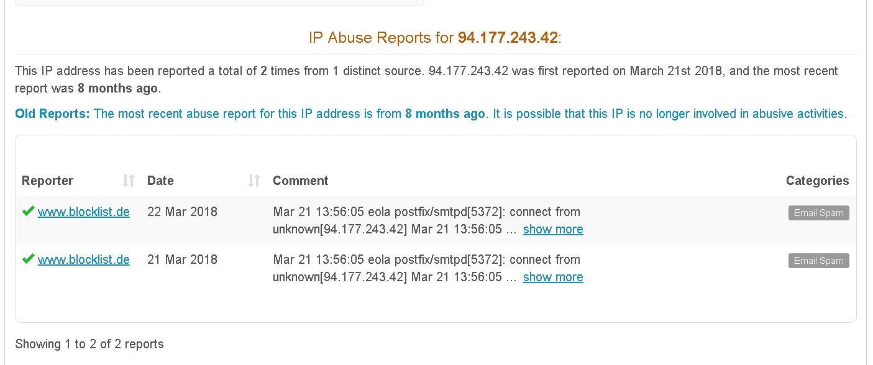

From the above analysis, it can be concluded that most of these IPs are involved in malicious activities. The best way to deal with them you can block them on your network and report them to Internet Service Provider or other authorities dealing with these kind of abuse.